Green fingered family of volunteers transform garden space for residents at Bucks care home
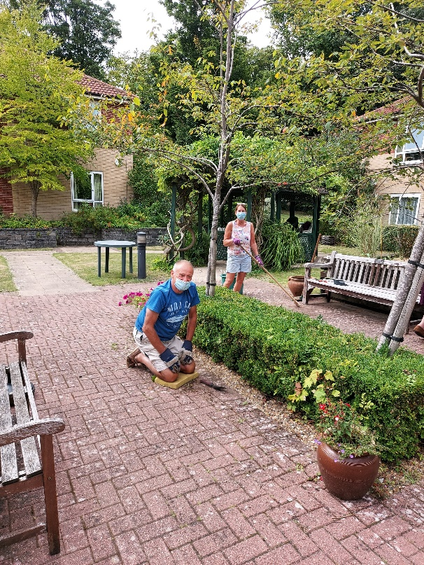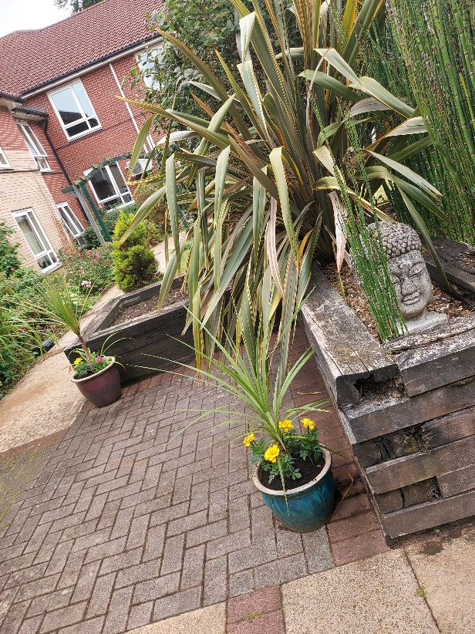

The advent of the COVID pandemic saw and end to life as normal for all of us across the country but none could have felt the impact greater than residents in care homes.
Ambient Support provides care and support for older people in a number of care settings and at one of its nursing homes in particular the lockdown saw the gardens and open spaces go a bit on the wild side – whilst visits from contractors and green fingered volunteers were suspended.
At Hazlemere Lodge in Buckinghamshire the easing of restrictions has meant that for one family they have been able to not only help bring the gardens back to their former glory but also enjoy socially distanced visits with loved ones.
Lucy Raine, Home Manager at Hazlemere Lodge says: “We were delighted when Richard Pitt and his wife Lynda volunteered to help out. Following a thorough risk assessment, the gardens at our home are once again looking fabulous.
“They have achieved a huge amount in such a short space of time, and we are so very grateful to them. It means that they, the residents and other family members can once again enjoy a pleasing and calming environment on socially distanced visits to Hazlemere Lodge.”
Richard added: “My mum has been at Hazlemere for just over a year. The team do a fantastic job providing personalised care for all the residents and they have worked especially hard during the recent health crisis.
“I volunteered and helped out with BBQ’s and events at the home last year but recognised that this year was going to be very different. It’s been great to be able to continue giving the home support.
“My wife and my sister have helped out and it’s the least we can do to help improve life for everyone. My mum was a great gardener in her time and she’s really enjoyed popping out and watching us help transform the space.”
Hazlemere Lodge is a purpose-built care home that provides nursing care and support and care for people living with dementia in Hazlemere. To find out more visit www.ambient.org.uk
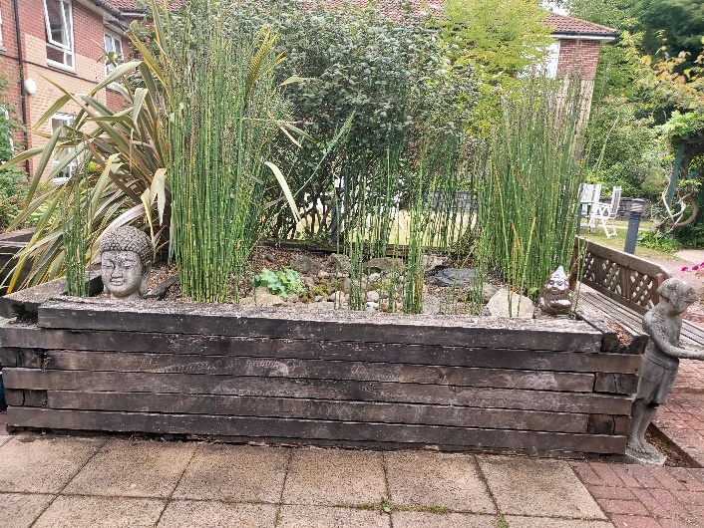
About Ambient:
Ambient Support (formerly known as Heritage Care and Community Options) is a registered UK charity with over 25 years’ experience in providing care and support services for older people, people with a mental health need and people with a learning disability. Ambient believe that everyone is unique, and they should be able to lead valued lives in their communities, treated with dignity and respect no matter their age, health condition or disability. To find out more visit www.ambient.org.uk
@ambient support

For more information, images or further commentary please contact Christina Wright chrissie@pr4.com +44 7957 383070 / kathy@pr4.com

About Ambient Support: www.ambient.org.uk
- One of the Top 20 generic Not-For-Profit Health & Social Care Providers in the UK Ambient Support (formerly known as Heritage Care and Community Options) is a registered UK charity with over 25 years’ experience
- They deliver services that meet the needs of some of the most vulnerable adults in our society. Operating in over 130 locations, they provide over 30 thousand hours of care to people on a weekly basis to support a range of needs due to the ageing process, learning disability or mental illness
- Their wide range of quality specialist services are delivered by dedicated, professional, and passionate staff and their success is built on supporting people to live a full and meaningful life.
- Ambient currently employs around 1,400 people across the UK in a number of settings
- Ambient can also help young adults who are transitioning from Children’s to Adult Learning Disability Services
- The Charity has an above industry average with 88% Registered Services rated as GOOD by CQC.

