Child-friendly career ideas

If you are looking for a career that works around the family and offers great progression and reward, then a career in social care could be just the thing.
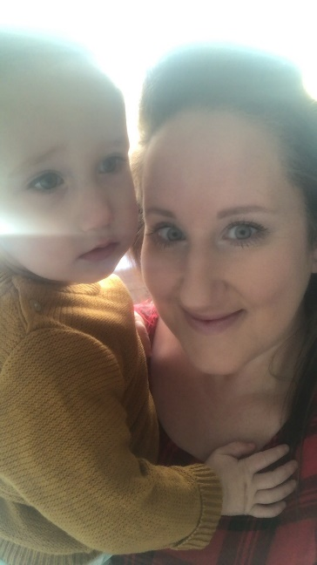

34-year-old Kayleigh Brown from Suffolk has been working for Ambient, a national care provider for 5 years. Here, she tells how her role in social care is far more rewarding and fun-filled than her former job in leisure, and how when she became pregnant, her job balanced perfectly with family life. In just 5 years, she has developed her skills and has progressed from Support Worker to Care Team Leader.

From holiday park to care
Kayleigh was working as a receptionist at a local holiday park in Norfolk but had become bored and fed up with the daily drudge and routine. She heard about Ambient (then called Heritage Care) and the ‘Support Worker’ role through a relative. The job sounded really interesting but initially she thought she couldn’t apply as she had no experience of working with people with a Learning Disability.

No experience needed
“I soon found out it wasn’t about having experience it was about having the right attitude and behaviours. In the end, I thought- why not apply, and see what happens.”

Kayleigh was successful and joined a team that provide one-to-one care for adults with learning disabilities in a supported living unit in Norfolk.

Every day is different
“When I started, my role was to support an adult, on a one to one basis, who has a learning disability and autism. Believe me when I say that no two days at work have ever been the same! One day we might be going shopping, the next I’m supporting them to attend activities and groups in the community or even just helping them cook a meal.”

Quick career progression
“Ambient is an employer that really encourages you to learn and grow as a person. Within 18 months I finished my QCF Level 2 in Social Care. Within 5 years, I became Team Leader in the scheme I work in. I set out to achieve this goal and with the support of Ambient, and my team, I achieved it! Now that my son is starting school, I am going to increase my hours and concentrate on Positive Behavioural Support which is a recognised approach to supporting people with disability and challenging behaviours.”

The perfect work-life balance
“I had been working for just over a year when I found out I was pregnant. I had no idea how it would work but Ambient were brilliant and when I came back after maternity leave, I moved from full time, to flexible hours.”

A team that care about each other
“The team I work with are amazing and I have great support from my colleagues. When I first started, they never made me feel stupid for asking questions. The culture and Ambient way of doing things mean that we all look out for each other. A good example is us sitting down as a team to do the rota to make sure the hours work for each of us.”

I genuinely make a difference to people’s lives
“Don’t get me wrong, it is hard work and sometimes days at work can be challenging, especially when people are upset or have behaviours that challenge…but the rewards are immense. Since I have been working with people with a disability, I have seen their communication skills improve, and it makes me really proud to think I might be part of that positive change.”

Is a career in care for you?
If I had to choose three words that summed up my job, they would be: challenging, rewarding, and inspirational …and if I was talking to someone who was thinking of applying, I would say… go for it! My only regret is that I didn’t have the confidence and belief in myself to apply for a role like this sooner.

“Isn’t care work just for older people?”
“I’ve recently taken on a 20-year-old girl as a new team member. Not only does she bring energy and ideas that are a breath of fresh air to those we are supporting, but she is feeling rewarded, satisfied, and excited about her progression. A career in care is about the attitude, not the age and I’d encourage anyone thinking about it to find out more.”

If you think a career in care could be for you, visit www.ambient.org.uk to find out more or email recruitment@ambient.org.uk.

