Head funds! – key worker shaves hair to raise over £500 for residents at Bucks care home
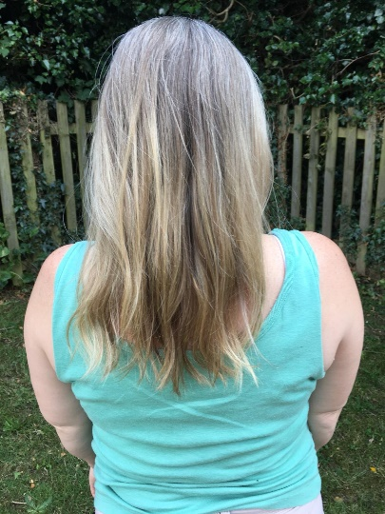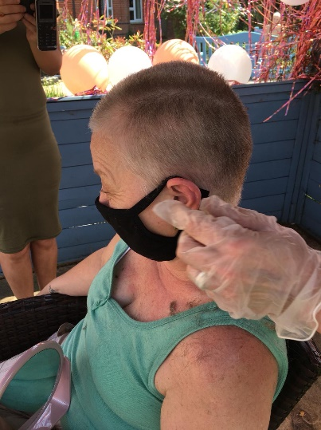

Andrea Learoyd is a keyworker for Ambient Support, a UK provider of social care, that look after some of the most vulnerable in our society.
In a feat of altruism, she has taken it upon herself to do something extraordinary to raise money in a bid to bring cheer and smiles to the faces of those at The Croft in Amersham, which provides personalised care and support to older people.

On Friday 26th June she shaved off her long blond hair and has raised over £500!

Andrea who has worked as a cook for 4 years at The Croft says, “There was nothing in particular I want the money to be spent on, I just wanted to give it to the service for the residents to choose a treat for themselves and bring some cheer during this period of lockdown.” https://www.justgiving.com/fundraising/andrea-learoyd

The event took place outside on Friday, with residents enjoying ice creams, bunting and balloons whilst cheering Andrea on as her locks were cut.
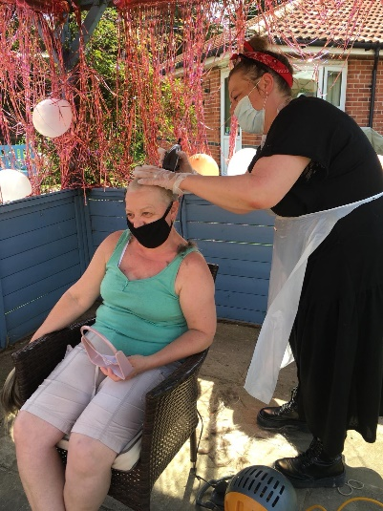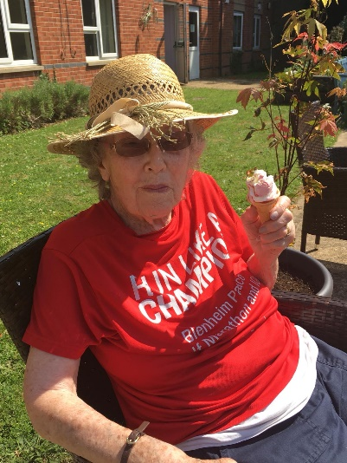

Now the challenge is complete, residents are deciding what they’d like to spend the money on with ideas including a Tropical fish tank and new games for the lounge or entertainment from a 50’s singer, a dancing dog and even a visit from the Chippendales!
Whilst the ideas are varied, all residents agreed that, no matter what, Andrea must be involved so she can be thoroughly thanked for all that she has done.
Louise Foyle-York, Manager at The Croft is extremely proud of Andrea and her courageous and selfless fundraiser:
“Andrea has gone above and beyond. She, and all the team here at The Croft are passionate about the people we care for and we look forward to seeing our lovely residents enjoy themselves with the funds raised.”

For more information, images or further commentary please contact Christina Wright chrissie@pr4.com +44 7957 383070

About Ambient:
Ambient Support (formerly known as Heritage Care and Community Options) is a registered UK charity with over 25 years’ experience in providing care and support services for older people, people with a mental health need and people with a learning disability. At Ambient, we believe that everyone is unique, and they should be able to lead valued lives in their communities, treated with dignity and respect no matter their age, health condition or disability. To find out more visit www.ambient.org.uk
@ambient support

- One of the Top 20 generic Not-For-Profit Health & Social Care Providers in the UK Ambient Support (formerly known as Heritage Care and Community Options) is a registered UK charity with over 25 years’ experience
- They deliver services that meet the needs of some of the most vulnerable adults in our society. Operating in over 130 locations, they provide over 30 thousand hours of care to people on a weekly basis to support a range of needs due to the ageing process, learning disability or mental illness
- Their wide range of quality specialist services are delivered by dedicated, professional, and passionate staff and their success is built on supporting people to live a full and meaningful life.
- Ambient currently employs around 1,400 people across the UK in a number of settings
- Ambient can also help young adults who are transitioning from Children’s to Adult Learning Disability Services
- The Charity has an above industry average with 88% Registered Services rated as GOOD by CQC.
- Ambient recently joined Amazon smile. ‘Ambient Support Limited’ is now a listed cause that people can choose to support when they shop via Amazon Smile to help raise funds.

