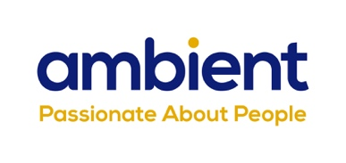
100km Peak District walk for wonderful Mum – daughter and granddaughter raise funds for Newark care home

(15th June, 2021) Local woman, Nikki Dawson, along with her daughter and friend will be walking a combined 100km on Saturday 3rd July at the Peak District Challenge to raise funds for her Mum’s Newark care home.

Nikki’s mum, Sue Marris, who is 75 and living with Alzheimer’s has been residing at Millbank care home since March 2020. Part of National Charity, Ambient Support Millbank provides care and support for older people including those living with dementia.

Sue has lived in the Newark area all her life. She worked as a hairdresser as a young woman and then married Ralph Marris in October 1966, who was a farmer in Long Bennington. The couple brought up their two daughters, Nikki and Liz, on the family farm and Sue was always very active helping to manage the business and run a busy household. An avid indoor and outdoor bowls player, Sue loved to compete and was part of the Lincolnshire County Team for some time.

Nikki is a keen walker but has never attempted such a long distance before. She says:
“I want to say thank you to the team at Millbank, they’ve done what I couldn’t and that’s provide a safe and happy environment so Mum can live her fullest and most contented life. I want to show our gratitude for all the love and support they have given her, especially throughout Covid. I hope the money raised will benefit both the residents and staff, developing their communal areas to further enhance residents’ lives and mental wellbeing would be fantastic.”

Diane Dunn, Manager at Ambient Support’s Millbank, says:
“We are incredibly grateful to Nikki for her fantastic fundraiser. The team at Millbank have worked tirelessly over the past year with everyone going above and beyond to ensure that all of our residents stay safe and happy. This is recognition for all of the hard work, it’s lovely and the staff are really excited to see Nikki and her team complete the challenge.”

Nikki will be walking 50km and her daughter, Jess, and her friend will both be walking 25km on 3rd July 2021 at the Peak District Challenge. To donate and help raise funds for Millbank care home, go to Nikki’s official Just Giving Fundraising page; https://www.justgiving.com/fundraising/nikki-dawson1

Millbank care home is an intimate Residential care home with just 37 personalised rooms available to both single residents and couples. Situated close to the heart of the historic market town of Newark, Millbank provides a friendly, supportive and welcoming home-from-home environment with regular and varied activities, outings and events.
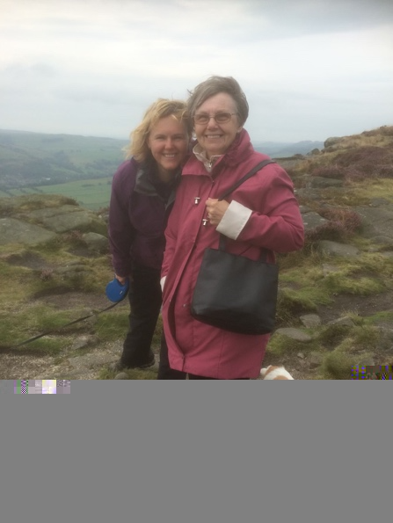
Image: Nikki Dawson and her Mum, Sue Marris, walking in the Peak District

~ENDS~

For more information, images or comment please contact:
Christina Wright chrissie@pr4.com +44 7957 383 070 & Kathryn Rivans kathy@pr4.com

About Ambient Support: www.ambient.org.uk @ambientsupport
- One of the Top 20 generic Not-For-Profit Health & Social Care Providers in the UK, Ambient Support (formerly known as Heritage Care and Community Options) is a registered UK charity with over 25 years’ experience
- They deliver services that meet the needs of some of the most vulnerable adults in society. Operating in over 130 locations, they provide over 30 thousand hours of care to people on a weekly basis to support a range of needs due to the ageing process, learning disability or mental illness
- Their wide range of quality specialist services are delivered by dedicated, professional, and passionate staff and their success is built on supporting people to live a full and meaningful life
- Latest results from Ambient Support’s 2021- Satisfaction Survey show: 97% of people supported in Learning Disability services said Ambient have helped to make their life better, 95% are happy with the support Ambient give them and 94% of relatives and friends said their loved one is safely supported by Ambient.
In Mental Health Services 93% said that staff believe in their wellbeing and recovery, 91% of people said they knew how to provide feedback or make a complaint and 89% report being given information and support to make choices
In services for Older People, 98% report being treated with kindness, dignity and respect and 97% of relatives agree, 91% of friends and relatives report that their loved one’s life has got better since Ambient started supporting them and 97% said that they are happy with the care and support they receive
- Ambient currently employs around 1,325 people across the UK in a number of settings
- Ambient can also help young adults who are transitioning from Children’s to Adult Learning Disability Services
- The Charity has an above industry average with 88% Registered Services rated as Outstanding and GOOD by CQC.

