Local care home calls for help to ‘grow’ funds for a garden polytunnel this National Growing for Wellbeing Week

(8th June, 2021) Staff at St Audrey’s care home in Old Hatfield are hoping to raise enough funds to buy a wheelchair accessible polytunnel that residents can use all year round with a series of summer fundraising events including a Talent Show, Sponsored Walk and Sports Day.

Part of National Charity, Ambient Support, St Audrey’s forms part of the Hatfield House Estate, a 19th Century Manor house with beautiful gardens. Residents enjoy gardening but are currently limited to summertime and are reliant on good weather, a polytunnel will enable residents to enjoy the benefits of gardening all year.

St Audrey’s Team members, Sian Oughton and Louise Salisbury put their heads together to organise the special events. Louise says:
“We cannot put into words how important gardening and growing is for our residents’ wellbeing, physical and mental health. It gives everyone an enormous sense of satisfaction and for some, they are learning a completely new skill which is fabulous at an older age.”
Louise continues:
“Buying and siting a wheelchair accessible polytunnel at St Audrey’s means our residents will be able to get their hands dirty and reap the benefits of gardening all year round. National Growing for Wellbeing Week, that celebrates the magic of growing, seems the perfect time to start spreading the word about our polytunnel fundraiser and asking the local community for their help.”

Family events throughout the summer will help to raise funds. St Audrey’s Got Talent on 26th June is a picnic-in-the-park occasion that will see staff and residents performing songs, dances and comedy acts. On 1st August, staff and family of residents will be taking part in a long-distance sponsored walk around Welwyn Garden City, hoping to walk 20km. Residents will also be joining in but will walk around St Audrey’s garden. There will also be a Family Day and a traditional Sports Day and a raffle with prizes donated by local companies will also help the charity.

Dawn Edworthy, Ambient team member and sponsored walk organiser says:
“The sponsored walk is a fantastic way to raise funds for the polytunnel and it also enhances relationships with our residents’ families- staying connected and building wider bonds is extremely important for us at Ambient and ultimately has a positive impact on residents, families and staff.”

Manager at St Audrey’s, Katie Hughes, says:
“The past year has been very difficult so it’s absolutely wonderful that we can welcome families back to St Audrey’s and enjoy time all-together again.
“I am extremely proud of the team for creating a summer of fun-filled fundraising events. Going above and beyond, their upmost determination, commitment and unwavering passion demonstrates how much they care about our residents and how good quality care is truly indispensable. I’m very much looking forward to all the fun!”

St Audrey’s is hoping to raise enough money to purchase a wheelchair accessible polytunnel and the cost to install it in the grounds of their garden. They are estimating around £5,000 will be required for the polytunnel and any monies left will be used to further develop the garden for residents.

All donations from the local community will be gratefully received, please got to the official St Audrey’s Just Giving page to donate.

If you are a local business and would like to provide a prize for the raffle, or you are a gardening or building company and can give time to help install the polytunnel, please contact louise.salisbury@ambient.org.uk.

St Audrey’s care home is an intimate Residential care home that is able to provide care and support to 35 residents. Forming part of the Hatfield House Estate, it is a beautiful 19th Century Manor house that provides a friendly, supportive and welcoming home-from-home environment with regular and varied activities and events.
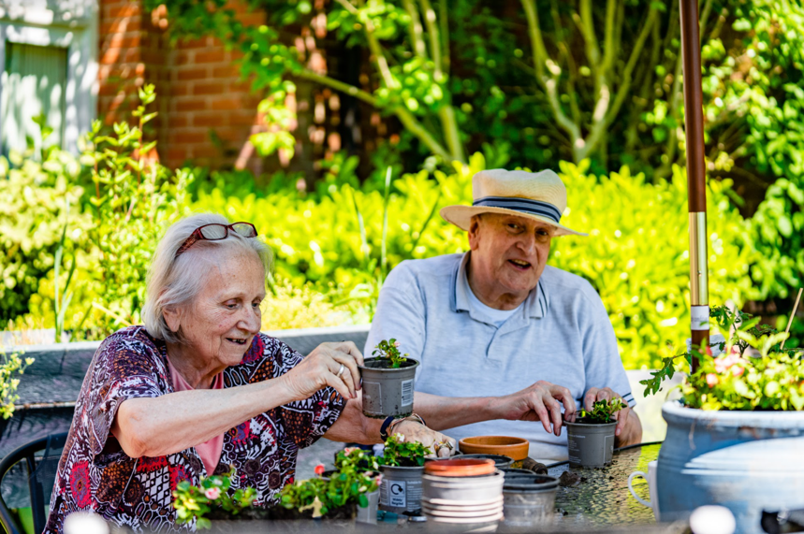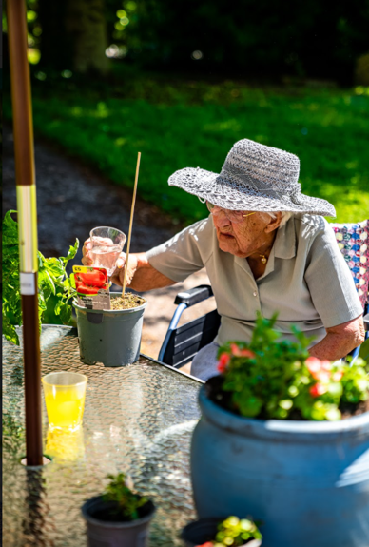
Image: ©George Salisbury: Green Fingered Residents at Ambient Support’s St Audrey’s Care Home
~ENDS~
For more information, images or comment please contact:
Christina Wright chrissie@pr4.com +44 7957 383 070 & Kathryn Rivans kathy@pr4.com

About Growing for Wellbeing Week: https://lifeatno27.com/ @LifeatNo27
- Growing for Wellbeing Week will take place on the 7th – 13th June 2021. Set up by social enterprise, Life at No.27, the week is a celebration of the magic that growing your own produce can do for your wellbeing, both physically and mentally.
- Approximately 1 in 4 people in the UK will experience mental ill health each year. There is strong evidence highlighting the health benefits of gardening and GYO in particular, including improved confidence, communication, concentration and ultimately self-belief.
- Gardening improves mental health, enables better physical health, provides an opportunity to connect with others, acquire new skills and enjoy the great outdoors.
About Ambient Support: www.ambient.org.uk @ambientsupport
- One of the Top 20 generic Not-For-Profit Health & Social Care Providers in the UK, Ambient Support (formerly known as Heritage Care and Community Options) is a registered UK charity with over 25 years’ experience
- They deliver services that meet the needs of some of the most vulnerable adults in society. Operating in over 130 locations, they provide over 30 thousand hours of care to people on a weekly basis to support a range of needs due to the ageing process, learning disability or mental illness
- Their wide range of quality specialist services are delivered by dedicated, professional, and passionate staff and their success is built on supporting people to live a full and meaningful life
- Latest results from Ambient Support’s 2021- Satisfaction Survey show: 97% of people supported in Learning Disability services said Ambient have helped to make their life better, 95% are happy with the support Ambient give them and 94% of relatives and friends said their loved one is safely supported by Ambient.
In Mental Health Services 93% said that staff believe in their wellbeing and recovery, 91% of people said they knew how to provide feedback or make a complaint and 89% report being given information and support to make choices
In services for Older People, 98% report being treated with kindness, dignity and respect and 97% of relatives agree, 91% of friends and relatives report that their loved one’s life has got better since Ambient started supporting them and 97% said that they are happy with the care and support they receive
- Ambient currently employs around 1,325 people across the UK in a number of settings
- Ambient can also help young adults who are transitioning from Children’s to Adult Learning Disability Services
- The Charity has an above industry average with 88% Registered Services rated as Outstanding and GOOD by CQC.

