How the ‘Branching Out’ horticultural project in Bromley is helping people improve their mental health and wellbeing

(9th June 2021, London) A Bromley-based volunteer gardening and horticulture project is helping to change lives and improve mental well-being for local people with lived experience of mental ill-health.

Run by national charity, Ambient Support - who deliver numerous mental health services across a range of settings in Bromley and surrounding Boroughs- ‘Branching Out’ welcomes volunteers into a relaxed, informal and supportive work environment.

Participants learn new skills in horticulture by completing commissioned gardening and maintenance services. The project runs three mornings a week and works across various Ambient services and private gardens locally. People interested in gardening maintenance services can call-the team for a competitive quote.

Trevor Thomas, who leads the project started volunteering aged 49 after having to give up his previous employment due to a back injury. He has been in the post for 8 years, and has seen how it has helped hundreds of people to build confidence and boost self-esteem.
Trevor, actively encourages people to join and says:
"Working in nature has a hugely positive impact on mental health, it puts you in the present moment and is a reminder of the beauty of the world. We don't want to put unnecessary pressure on our volunteers who have lived experience of mental health so there is plenty of flexibility in what we do. This means that we’re always looking for new volunteers who can get involved and help when they feel able.
"Most of our services and gardening projects are local. We are looking to the future and plan on building raised beds across the mental health services we look after. We aim to support people at the services to fill these beds with vegetables and herbs. They can water and care for the herbs when the Branching Out team isn’t there and maybe even cook with them- this really will bring positive benefits to peoples’ wellbeing.”
To find out more about becoming a volunteer or to donate to the Branching Out project, watch their video here or visit the Branching Out page on Ambient’s website.

CASE STUDY DETAILS – FROM VOLUNTEER TO PROJECT LEAD
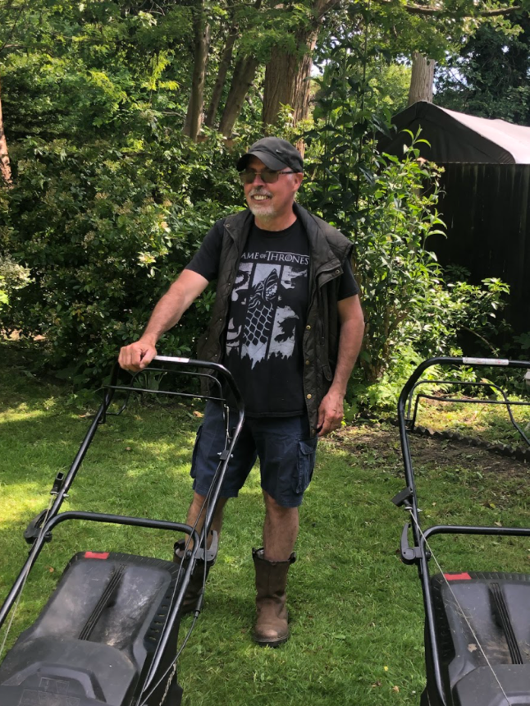
IMAGE: Trevor Thomas Manager at Ambient Support’s Branching Out Project in Bromley

Trevor started volunteering aged 49 after having to give up his previous employment due to a back injury.

He started out with Bromley Field Studies project at Scadbury Park as part of a return-to-work scheme. Subsequently, he joined the newly formed Branching Out Project which was a joint initiative with MIND and Community Options.

Showing promise, he was invited to be an Assistant to the then Project Lead. He now is the Project Lead himself hand has been successfully running the scheme for the past 8 years.

Over this time, Trevor and Branching Out have worked with 100’s of other volunteers, building confidence and self-esteem of people with lived experience of mental illness. Many have gone on to get formal horticulture qualifications and have returned to work or further studies.

The project is now so successful that in order to reach more people they need a new van. They have established a base with poly tunnels at an Ambient Service in Bromley but also provide gardening services to private individuals in the surrounds.

Being a volunteer has been transformational for Trevor, learning new skills and building his knowledge which he now is able to pass on to others.

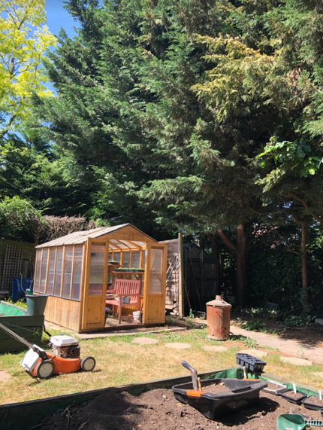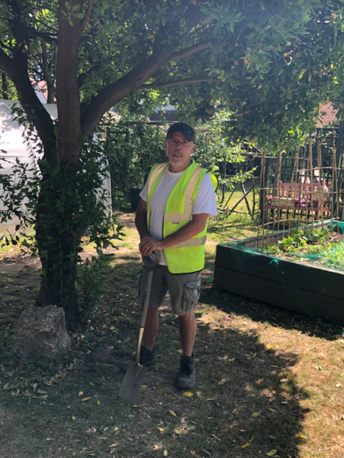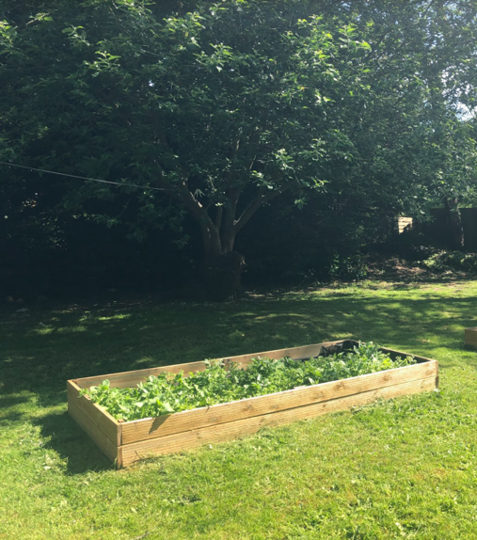
IMAGES: Ambient Support’s Branching Out Horticultural Project in Bromley

~ENDS~
For more information, images or comment please contact:
Christina Wright chrissie@pr4.com +44 7957 383 070 & Kathryn Rivans kathy@pr4.com

About Growing for Wellbeing Week: https://lifeatno27.com/ @LifeatNo27
- Growing for Wellbeing Week will take place on the 7th – 13th June 2021. Set up by social enterprise, Life at No.27, the week is a celebration of the magic that growing your own produce can do for your wellbeing, both physically and mentally.
- Approximately 1 in 4 people in the UK will experience mental ill health each year. There is strong evidence highlighting the health benefits of gardening and GYO in particular, including improved confidence, communication, concentration and ultimately self-belief.
- Gardening improves mental health, enables better physical health, provides an opportunity to connect with others, acquire new skills and enjoy the great outdoors.
About Ambient Support: www.ambient.org.uk @ambientsupport
- One of the Top 20 generic Not-For-Profit Health & Social Care Providers in the UK, Ambient Support (formerly known as Heritage Care and Community Options) is a registered UK charity with over 25 years’ experience
- They deliver services that meet the needs of some of the most vulnerable adults in society. Operating in over 130 locations, they provide over 30 thousand hours of care to people on a weekly basis to support a range of needs due to the ageing process, learning disability or mental illness
- Their wide range of quality specialist services are delivered by dedicated, professional, and passionate staff and their success is built on supporting people to live a full and meaningful life
- Latest results from Ambient Support’s 2021- Satisfaction Survey show: 97% of people supported in Learning Disability services said Ambient have helped to make their life better, 95% are happy with the support Ambient give them and 94% of relatives and friends said their loved one is safely supported by Ambient.
In Mental Health Services 93% said that staff believe in their wellbeing and recovery, 91% of people said they knew how to provide feedback or make a complaint and 89% report being given information and support to make choices
In services for Older People, 98% report being treated with kindness, dignity and respect and 97% of relatives agree, 91% of friends and relatives report that their loved one’s life has got better since Ambient started supporting them and 97% said that they are happy with the care and support they receive
- Ambient currently employs around 1,325 people across the UK in a number of settings
- Ambient can also help young adults who are transitioning from Children’s to Adult Learning Disability Services
- The Charity has an above industry average with 88% Registered Services rated as Outstanding and GOOD by CQC.

