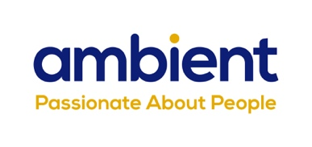

Launch of dynamic internal comms platform, Workvivo, signifies a new era for Ambient Support

(16th February 2022) National charity, Ambient Support, one of the top 20 generic Not-For-Profit Health & Social Care Providers in the UK, launches Workvivo, a tailored internal communications platform designed to elevate employee experience and bring teams together across the Charity, and sees engagement triple compared with its traditional intranet platform.

Following the successful rebrand of Ambient Support in April 2020, it was recognised that the next drive for repositioning and modernisation of the charity was to tackle internal communication and culture. Following a comprehensive tendering process which involved people from all tiers of the organisation, a SaaS (Software as a Service) provider was chosen and the platform was launched in January 2022.

This new digital channel allows for real time communication, sharing of best practice, quick access to Ambient’s documents database and it allows colleagues to create online communities.

One month from launching, Ambient recorded active users and engagement tripling compared with its traditional email and intranet platforms. Results from the first Pulse survey were overwhelming positive, showing that 90% of employees found Workvivo easy to use, 94% said they could access documents more quickly and 94% said they feel more involved with Ambient.

Davina Sellick, Director of Marketing & Communications, said:
“The launch of Workvivo heralds a new era within Ambient Support. For the first time in our history, our teams have a communal area and space within which they are able to share real time news, views and best practice with colleagues from across the charity. The functionality available to us within Workvivo means that in the coming months we will be rolling out a raft of initiatives including livestream broadcasts, pulse surveys and the introduction of a new staff reward and recognition schemes, all within this new platform.

“This initiative sits firmly within our strategy to revolutionise our digital assets and ways of working with those we support and our frontline teams. Additionally, it helps us build upon and strengthen the strong internal culture that already exists within Ambient, solidifying the links to our value set and the very heart of our way of working we call ‘The Ambient Way.’”
Lee Hodgson, Chief Information Officer:
“Workvivo is as innovative and dynamic an internal communication platform as I have ever come across and the benefits it will provide Ambient Support are immediate. Workvivo will form the gateway to our digital estate, making accessing our other systems simple and intuitive for all our teams.

“Workvivo was the first step towards modernising our technology capabilities, and will be followed closely by our finance system and the introduction of our newly procured enterprise care and support system.”

Feedback from Ambient employees includes:
“Everything I need for work is all in one place.”

“It is nice to see that we are capturing good things about what we do.”

“I think it's a really positive tool that will have an enormous impact on the staff teams. Great Job!”

John Goulding, CEO of Workvivo, said:
"We are delighted to be chosen as Ambient’s internal communications platform as the company begins to revolutionize their digital assets and how they support their frontline teams.

“At Workvivo we believe the culture of the company is owned by and shaped by everyone, a belief shared by the team at Ambient Support. We've seen how having an internal communications platform can bring company values to life and create a real sense of community. This is an exciting time at Ambient as they begin the rollout of a number of employee engagement initiatives and we are excited to be chosen as the gateway to Ambient’s digital estate."

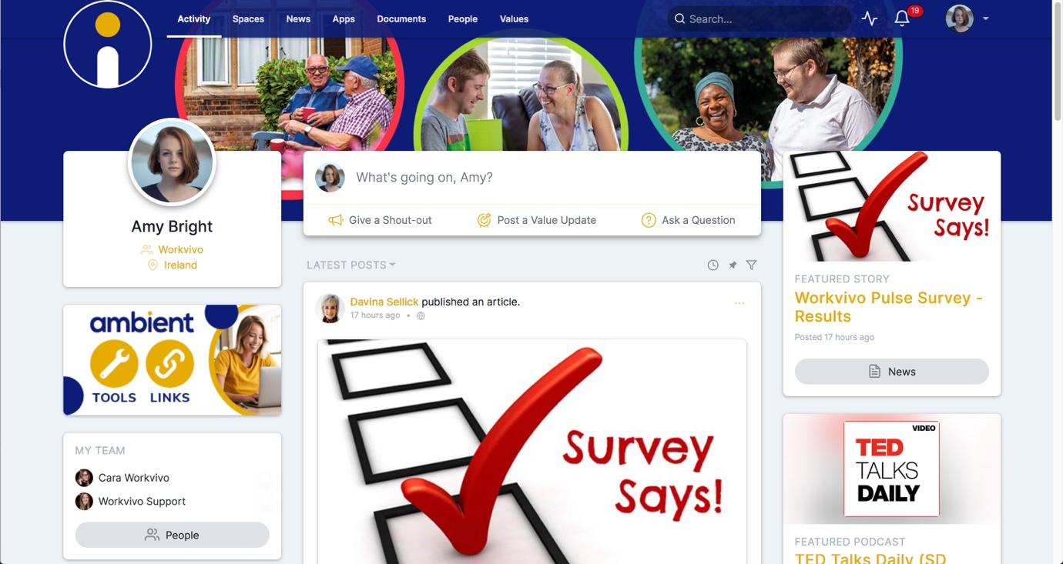

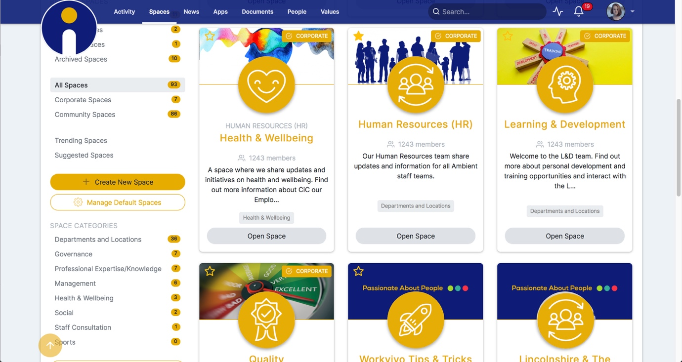

IMAGES: Screen shots of Ambient Support’s new internal comms Workvivo platform

www.ambient.org.uk

~ENDS~

For more information, images or comment please contact: Christina Wright chrissie@pr4.com +44 7957 383 070 & Kathryn Rivans kathy@pr4.com

Notes to Editors:
About Ambient Support: www.ambient.org.uk @ambientsupport
- One of the Top 20 generic Not-For-Profit Health & Social Care Providers in the UK, Ambient Support (formerly known as Heritage Care and Community Options) is a registered UK charity with over 25 years’ experience
- They deliver services that meet the needs of some of the most vulnerable adults in society. Operating in over 130 locations, they provide over 30 thousand hours of care to people on a weekly basis to support a range of needs due to the ageing process, learning disability or mental illness
- Their wide range of quality specialist services are delivered by dedicated, professional, and passionate staff and their success is built on supporting people to live a full and meaningful life
- Latest results from Ambient Support’s 2021- Satisfaction Survey show: 97% of people supported in Learning Disability services said Ambient have helped to make their life better, 95% are happy with the support Ambient give them and 94% of relatives and friends said their loved one is safely supported by Ambient.
In Mental Health Services 93% said that staff believe in their wellbeing and recovery, 91% of people said they knew how to provide feedback or make a complaint and 89% report being given information and support to make choices
In services for Older People, 98% report being treated with kindness, dignity and respect and 97% of relatives agree, 91% of friends and relatives report that their loved one’s life has got better since Ambient started supporting them and 97% said that they are happy with the care and support they receive
- Ambient currently employs around 1,325 people across the UK in a number of settings
- Ambient can also help young adults who are transitioning from Children’s to Adult Learning Disability Services
- The Charity has an above industry average with 88% Registered Services rated as Outstanding and GOOD by CQC.

