Lord-Lieutenant presents local Lincs man, John Gorée, with British Empire Medal to honour 4 exceptional decades in social care

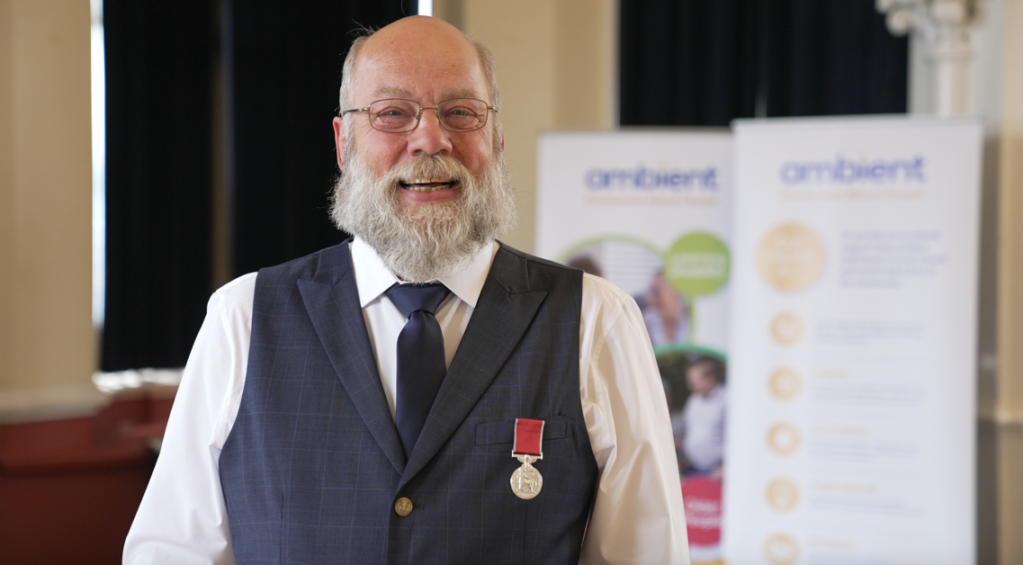
Image: John Gorée is formally recognised for his contribution
to social care ©Andrew Deptford

(Tuesday 24th May 2022) John Gorée was formally presented with the British Empire Medal (BEM) by Her Majesty’s Lord-Lieutenant of Lincolnshire this week in recognition of his services to the disabled in Lincolnshire and the Midlands.

The special ceremony was held at the Guildhall in Grantham where official speeches and medal presentation were followed by relaxed refreshments and was attended by close family, friends and colleagues from national charity, Ambient Support.

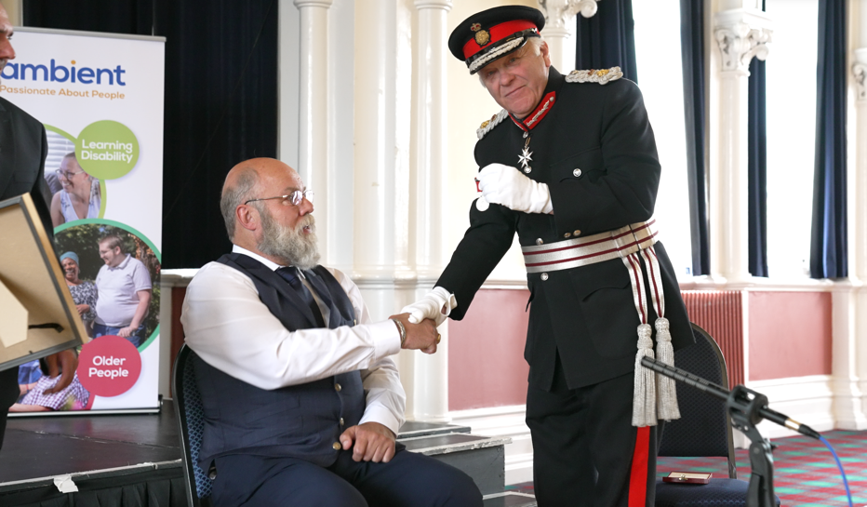
Image: John Gorée is presented with his British Empire Medal by the Lord-Lieutenant ©Andrew Deptford

Her Majesty’s Lord-Lieutenant of Lincolnshire, Toby Dennis, says:
“There is definitely something about Grantham, over the last few months I have been privileged to meet people from very different walks of life who have received national honours and John is continuing that wonderful spirit of community activity with the work he has done over the last four decades for his service in social care. I am delighted that, on behalf of Her Majesty The Queen, I am able to present John with the Medal of the Order of the British Empire.”

John started his career in 1982 as a care assistant then trained as a Learning Disability nurse in the NHS in 1985 before moving into social care where he joined Ambient Support 21 years ago. Prior to his retirement in May last year, John oversaw a team looking after 269 service users as Regional Manager for the Lincolnshire and The Midlands.

John’s passion was to ensure that a ‘person-centered’ approach was at the very heart of decision making at every level of the charity and he introduced news ways of thinking and devised many schemes and projects that realised this type of care.

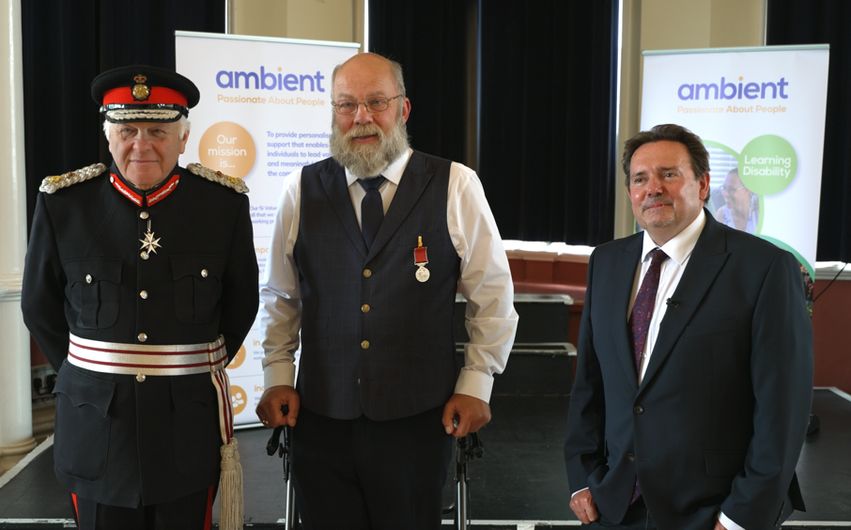
Image: Lord-Lieutenant, John Gorée and CEO of Ambient Support, Mark Milton ©Andrew Deptford

CEO of Ambient, Mark Milton, says:
“It was truly delightful to see so many people gather together to celebrate John’s outstanding career. His services to Ambient alone have been thoroughly commendable- a true trail blazer for change and a fearless advocate for people with disability and a pioneer in ensuring the voices of the people we support, are heard. We are forever grateful for his enthusiasm, dedication and his willingness to believe that everyone can lead a valued and meaningful life. John truly encapsulates what we call, ‘The Ambient Way’.”

On being presented with the BEM, John says:
“I feel truly thankful and humbled to receive the British Empire Medal surrounded by so many people who mean so much to me. My family and friends are forever supportive and I am eternally grateful to have worked with such fantastic teams of people in the Midlands and Lincolnshire at Ambient Support- we come to work every day with a smile, even when it’s difficult, knowing that we can make a positive impact to individual lives.”

The ‘John Gorée Awards’ were launched by Ambient last November as a way of honouring the retired Regional Manager following his 40-year career. John has generously donated £5,000 to the charity to run the award scheme in his name over the next 10 years which celebrates staff who deliver exceptional care and support to the people they look after.

Find out about The John Gorée Award, here

And Ambient’s services across The Midlands and Lincolnshire here: www.ambient.org.uk

~~ENDS~~

For images or additional comment please contact Chrissie@pr4.com +44 7957 383070 AND Kathy@pr4.com +44 7788 272009

Notes to Editors:
About Ambient Support: www.ambient.org.uk @ambientsupport
- One of the Top 20 generic Not-For-Profit Health & Social Care Providers in the UK, Ambient Support (formerly known as Heritage Care and Community Options) is a registered UK charity with over 25 years’ experience
- They deliver services that meet the needs of some of the most vulnerable adults in society. Operating in over 120+ locations, they provide over 30 thousand hours of care to people on a weekly basis to support a range of needs due to the ageing process, learning disability or mental illness
- Their wide range of quality specialist services are delivered by dedicated, professional, and passionate staff and their success is built on supporting people to live a full and meaningful life
- Latest results from Ambient Support’s 2021- Satisfaction Survey show: 97% of people supported in Learning Disability services said Ambient have helped to make their life better, 95% are happy with the support Ambient give them and 94% of relatives and friends said their loved one is safely supported by Ambient.
In Mental Health Services 93% said that staff believe in their wellbeing and recovery, 91% of people said they knew how to provide feedback or make a complaint and 89% report being given information and support to make choices
In services for Older People, 98% report being treated with kindness, dignity and respect and 97% of relatives agree, 91% of friends and relatives report that their loved one’s life has got better since Ambient started supporting them and 97% said that they are happy with the care and support they receive
- Ambient currently employs around 1,150+ people across the UK in a number of settings
- Ambient can also help young adults who are transitioning from Children’s to Adult Learning Disability Services
- The Charity has an above industry average with 88% Registered Services rated as Outstanding and GOOD by CQC.

