Walking the Wash with Autism

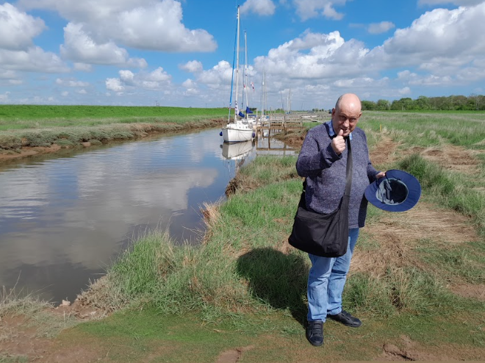

(05 July 2023) A man with autism spectrum disorder (ASD) who lives in supported living accommodation in Lincolnshire has taken two years to walk the Wash with the help of his care workers to raise awareness of Autism and to promote the Wash becoming a UNESCO World Heritage Site.

Chris, age 51, completed his 42-mile challenge in small 3-to-4-mile sections to overcome logistical obstacles and fitness limitations such as Chris’ asthma. He was supported throughout his journey by his care workers; Sylwester Oleksiewicz, Tomasz Wilf, Alex Kay and team leader Kim Wainwright, from a Learning Disability Service in Lincolnshire run by national charity, Ambient Support.

Chris says:
“I lived in London for 24 years. The countryside is so different. Being outside helped me to feel a part of my community and it helped my fitness. And I learned more about my ancestors and where I have come from.”

The Wash is a rectangular bay and multiple estuary at the north-west corner of East Anglia on the East coast of England, where Norfolk meets Lincolnshire bordering the North Sea. Stretching from Skegness to the Norfolk town of Hunstanton, the Wash is the largest national nature reserve by area covering almost 8,800 hectares. Five major rivers flow into the North Sea at the Wash; The Steeping River, Whitham, Welland, Nene and Great Ouse.

Sylwester, care worker at Ambient Support and Chris’s main companion throughout his journey, says:
“The Wash is one of the few last wildernesses in England, and it is a living environment that changes all the time according to the seasons and the ebbs and flows of the tide. It’s very beautiful but also challenging and demanding in terms of walking it.

“At Ambient, we are committed to providing person-centred, responsive support to the people we care for, following an ‘Active Support’ approach that helps people gain skills, confidence, and control of their lives. And so, helping Chris achieve his dream of walking the Wash was incredibly important to us as a team.”

Chris set off in April 2021 and completed his challenge in May 2023- he walked approximately 42 miles of the 80-mile Wash walk and visited the mouth of every river. Encountering plenty of wildlife along the way including otters, seals, geese, ospreys, cranes, sea scurvy and marsh samphire. Chris regularly helped to collect litter on the way to keep the environment clean and also experienced outside cooking.

Chris continues:
“My favourite parts included crossing the river Great Ouse by ferry and exploring King’s Lynn. We met lots of people along the way including foreign tourists, a nice HM prison guard who took us across HM Prison North Sea Camp, and we even helped search for a lost dog.”

In April the UK government announced that England’s east wetlands including the Wash are being put forward as a potential UNESCO World Heritage Site and Chris hopes his walk will raise awareness of the campaign.

Chris and his key care worker, Sylwester, developed a strong bond during the challenge and share a similar taste for adventure and being in the great outdoors.

Sylwester, says:
“I feel honored to have shared this journey with Chris. The sheer distance was an enormous challenge for him, and over the two years we experienced all kinds of weather, sometimes four seasons in one day. It was tough at times, but we were disciplined, and Chris never gave up- his perseverance and enthusiasm was inspiring. The joy and excitement of being outdoors spurred us on.”

Of future walking plans, Sylwester, says:
“We are inviting other Ambient Support staff and people we support to walk with Chris every month over the summertime. Walks are about 5,000 steps and last around one hour. We have food and drinks al fresco, and we ensure that walks are wheelchair friendly and there is access to toilets. The walk in August will be at Ferry Meadows in Peterborough.”

Chris lives in a supported living service run by national charity, Ambient Support, find out more about the service HERE and at www.ambient.org.uk

~~ENDS~~

FOR IMAGES OF CHRIS AND SYLWESTER SEE HERE

For images or additional comment please contact Chrissie@pr4.com +44 7957 383070 or kathy@pr4.com +44 7788 272 009

Notes to Editors:
About Ambient Support: www.ambient.org.uk @ambientsupport
- Ambient Support is one of the Top 20 generic Not-For-Profit Health & Social Care Providers in the UK
- They deliver services that meet the needs of some of the most vulnerable adults in society
- Operating in 110+ locations, they provide over 30 thousand hours of care to people on a weekly basis to support a range of needs due to the ageing process, learning disability or mental illness
- Ambient is certified as a Great Place to Work following an in-depth survey of staff in October 2022. Survey findings showed that 84% said they felt they made a difference and were proud of what they accomplished. Whilst almost 90% said they are treated fairly, regardless of age, race, or sexual orientation. Similarly, 83% of employees said that when they joined Ambient, they were made to feel welcome
- Ambient’s range of quality specialist services are delivered by dedicated, professional, and passionate staff and their success is built on supporting people to live a full and meaningful life
- Latest results from Ambient Support’s 2022- People We Support Satisfaction Survey show:
82% believe that Ambient supports them to live their life in the way they want to and 85% say we have helped make their lives better since support them.​ A total of 82% of people would tell others that they like Ambient
- Ambient currently supports around 950+ people across the UK in a number of care settings
- Ambient can also help young adults who are transitioning from Children’s to Adult Learning Disability Services
- 89% of CQC registered locations rated Good or Outstanding
- Ambient Support partners with EasyFundraising which allows people to turn their everyday online shopping purchases into donation funds for the charity, without costing extra money. Find out more HERE and visit Ambient’s EasyFundraising link HERE

