Return of Summer Fete raises over £700 for Aylesbury care home

(23 August 2023) The Chestnuts, a community-based care home in Aylesbury run by national charity, Ambient Support, raised over £700 thanks to the return of their annual Summer Fete this week. The event was officially opened by Downtown Abbey actor, Peter Egan who is brother to one of the people supported at the service.

The gardens at the Chestnuts were transformed into a traditional British summer fete with hook-a-duck, lucky dip, tombola, a hot dog stand, an ice-cream van, cake and Pimm’s stalls, tombola, and raffle. The local petting zoo, The Bucks Goat Centre, brought goats and ferrets for people to pet and hold.

The event was enjoyed by the people supported at the care home, their family and friends and members of the local community, with all proceeds directly benefiting the care home.

Actor, Peter Egan officially opened the fete with a welcoming speech, he said:
“It’s wonderful to be here today. My brother is here, he’s a resident at this wonderful care home, the Chestnuts, and they look after all of their guests here really beautifully. I’m very, very happy and feel very lucky that he is here. Big round of applause for everyone here today, have a great day.”

Simone Cotter, Manager at Ambient Support’s the Chestnuts, says:
“It was a joyful celebration, and we are incredibly thankful to the families and staff who donated gifts, baked cakes, and gave up their time to create such a fantastic event. We work extremely hard to provide a friendly, supportive, and welcoming home from home environment at the Chestnuts and believe that everyone deserves to live a meaningful and full life regardless of age and through this event we’ve not only raised money for the people we support but given them and their families memories to cherish.

“It was wonderful to see different family members mingle together and talk about their experiences of the care home, we received some really good feedback about how lovely the Chestnuts is which is always good to hear, especially as the staff teams go above and beyond on a daily basis.”

Mick Egan, who is supported at the Chestnuts, says:
“It was a lovely day with lots of joy and laughter. There were people of all ages having fun, just like a family garden party. A really happy day.”

The Chestnuts is a community-based residential care home in Aylesbury able to provide a home to 64 people, and can support up to 48 residents with specific dementia care needs.
For more details on Ambient services at the Chestnuts click here

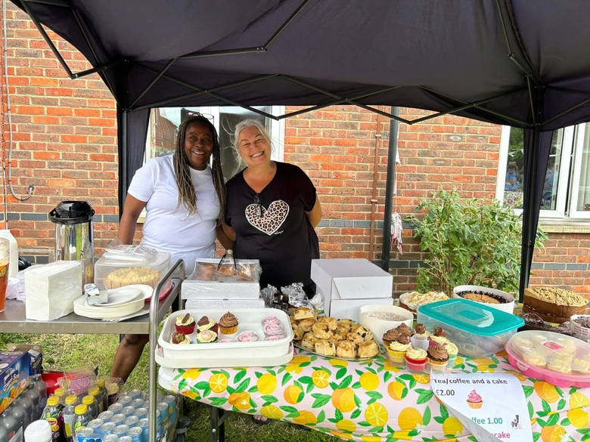
Maureen Buck Senior Care Assistant, and Julie Parkyn Care Assistant from Ambient Support

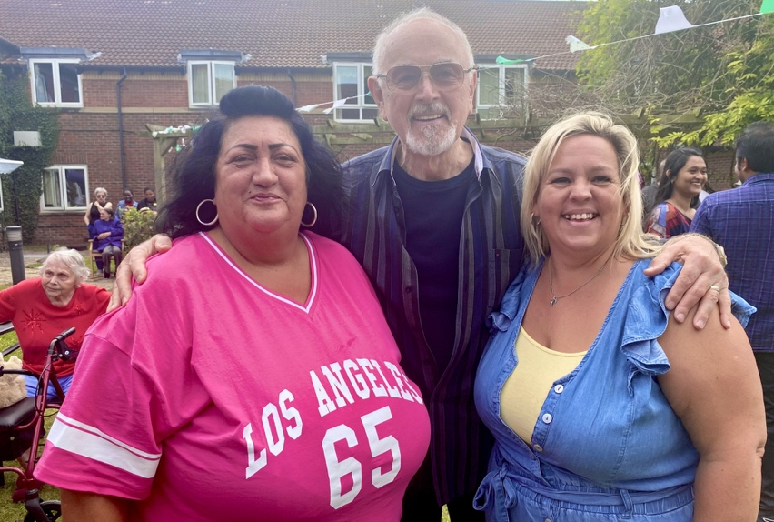
Simone Cotter, Manager of Ambient Support’s the Chestnuts, Actor Peter Egan, and Carla Downie, Activity Organiser

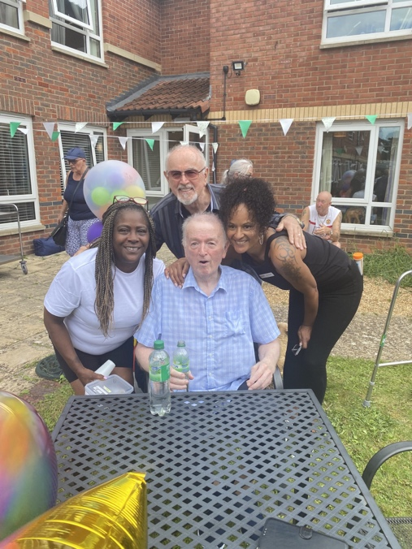
Maureen Buck, Actor Peter Egan with his brother Mick Egan who is supported by the Chestnuts and Dawn Rickard Care Team Leader

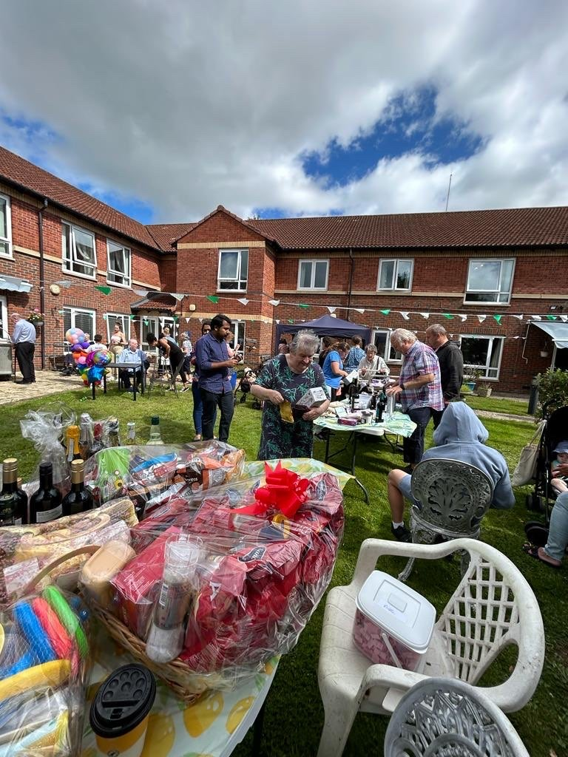
The Chestnuts gardens were transformed for the day
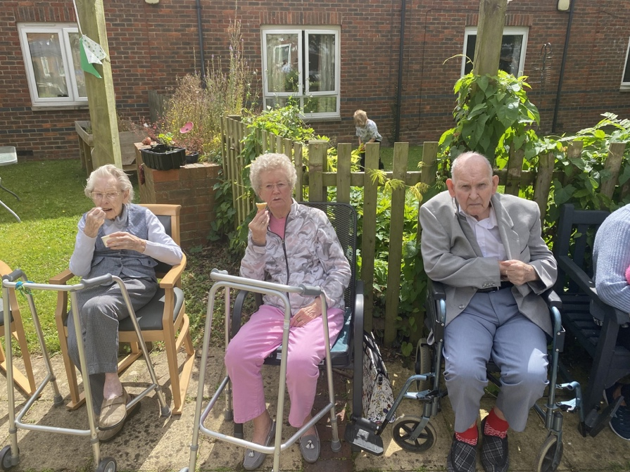
People supported by Ambient’s the Chestnuts, enjoying the day

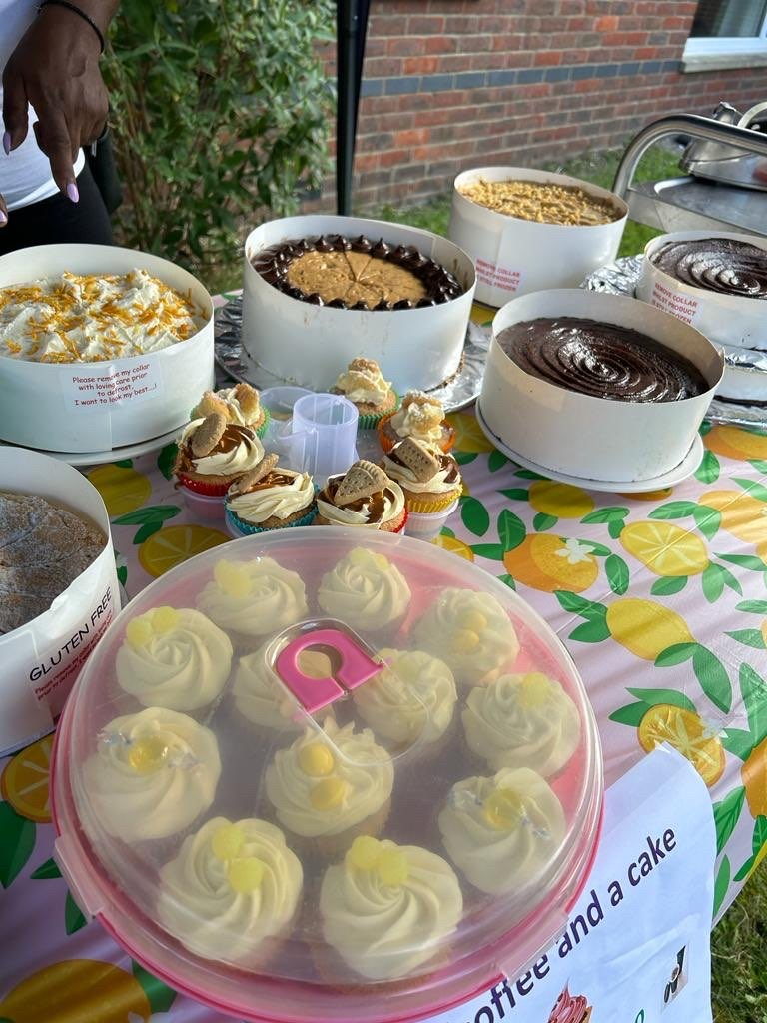
Many family members supported the day by baking cakes for all to enjoy

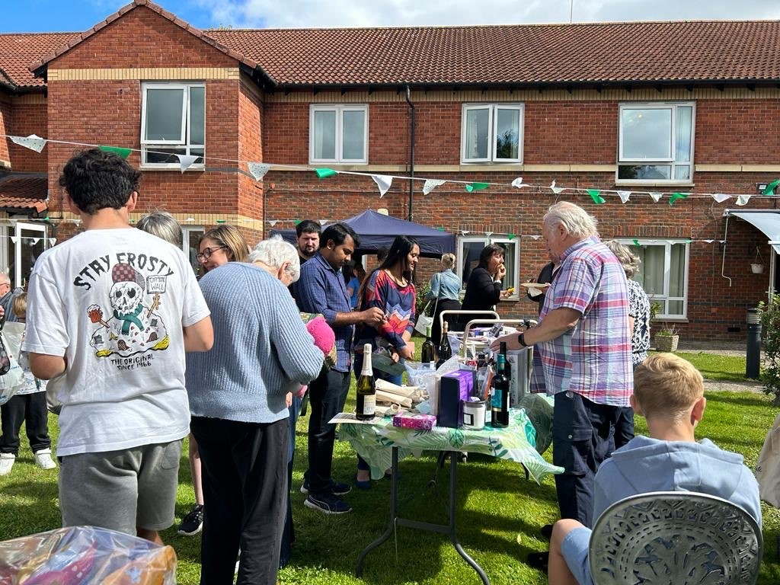
The garden-party atmosphere was enjoyed by all

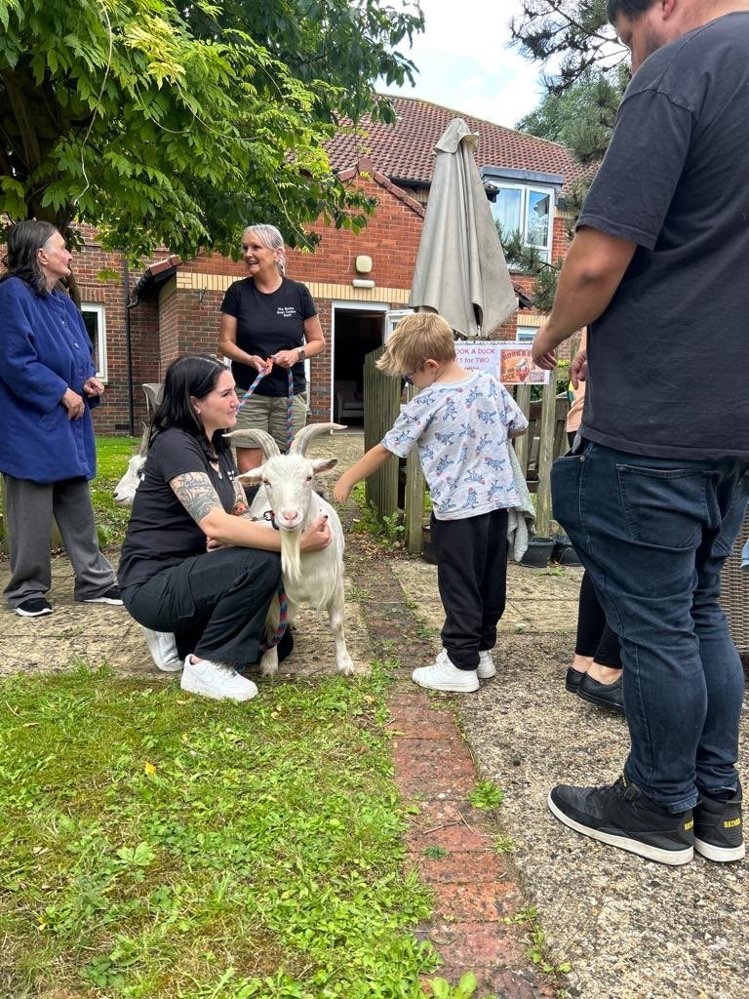
All ages enjoyed petting the animals from The Bucks Goat Centre
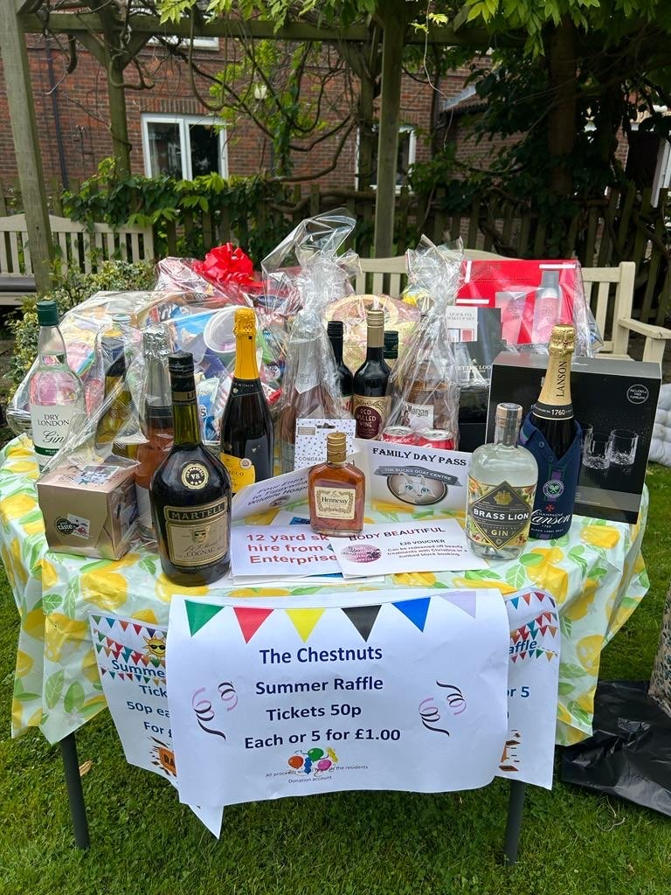
Generous donations from family, friends and Ambient staff ensured money was raised for the Chestnuts

~ENDS~

For images or additional comment please contact Kathy@pr4.com +44 7788 272009
Notes to Editors:
About Ambient Support: www.ambient.org.uk @ambientsupport
- Ambient Support is one of the Top 20 generic Not-For-Profit Health & Social Care Providers in the UK
- They deliver services that meet the needs of some of the most vulnerable adults in society
- Operating in 110+ locations, they provide over 30 thousand hours of care to people on a weekly basis to support a range of needs due to the ageing process, learning disability or mental illness
- Ambient is certified as a Great Place to Work following an in-depth survey of staff in October 2022. Survey findings showed that 84% said they felt they made a difference and were proud of what they accomplished. Whilst almost 90% said they are treated fairly, regardless of age, race, or sexual orientation. Similarly, 83% of employees said that when they joined Ambient, they were made to feel welcome
- Ambient’s range of quality specialist services are delivered by dedicated, professional, and passionate staff and their success is built on supporting people to live a full and meaningful life
- Latest results from Ambient Support’s 2022- People We Support Satisfaction Survey show:
82% believe that Ambient supports them to live their life in the way they want to and 85% say we have helped make their lives better since support them.​ A total of 82% of people would tell others that they like Ambient
- Ambient currently supports around 950+ people across the UK in a number of care settings
- Ambient can also help young adults who are transitioning from Children’s to Adult Learning Disability Services
- 89% of CQC registered locations rated Good or Outstanding
- Ambient Support partners with EasyFundraising which allows people to turn their everyday online shopping purchases into donation funds for the charity, without costing extra money. Find out more HERE and visit Ambient’s EasyFundraising link HERE

