Older People and Learning Disability Services Unite Across Suffolk for Halloween Party

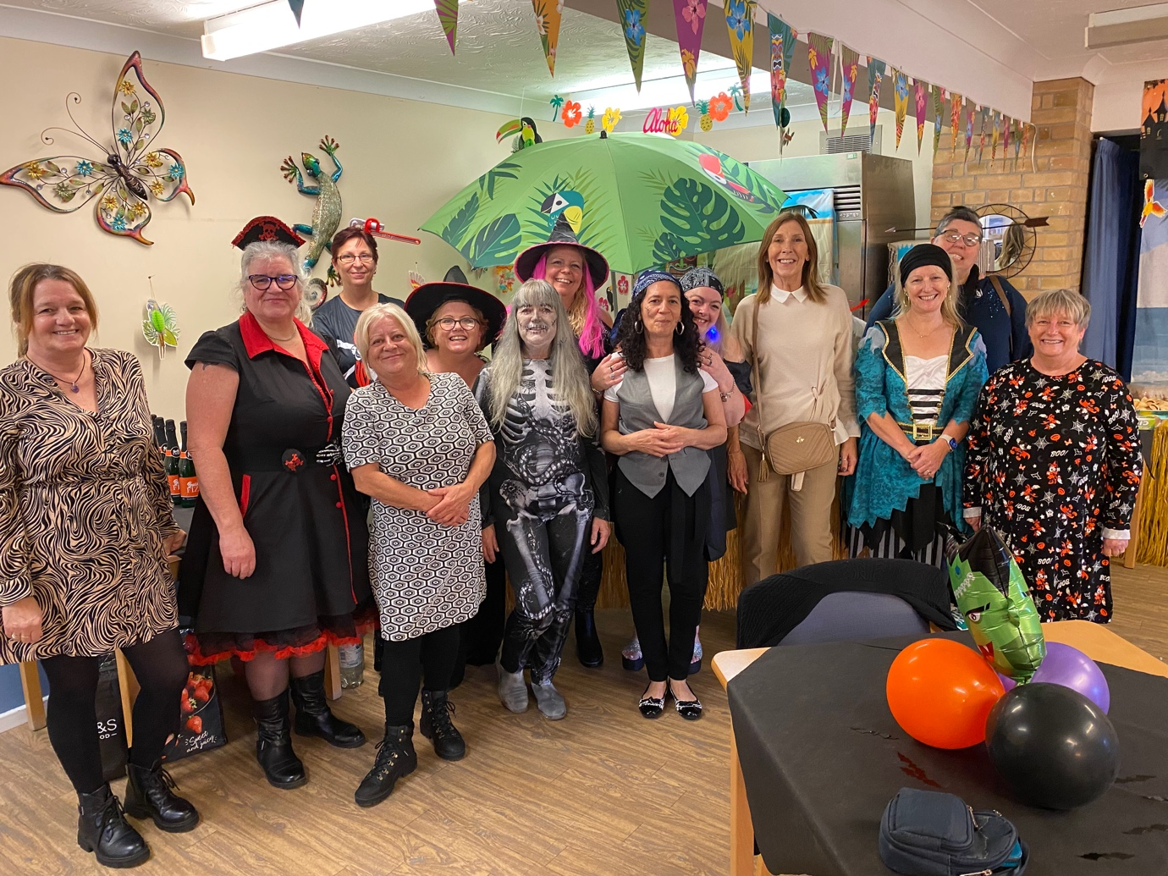
Ambient Support staff at Peppercorn House in Ipswich and Learning Disability Services across Suffolk created an inclusive and fun environment for people supported by the charity ©Ambient Support

(30 October 2023) The Ambient staff team at Peppercorn House, an Older People extra care service in Ipswich threw a Pirates of the Caribbean themed Halloween party this week- and extended the invite to welcome individuals and their support workers from Ambient’s Learning Disability services across Suffolk.

The Halloween party was headlined by a local Ipswich-based musician who entertained the guests with a repertoire of upbeat and popular songs. Staff and guests dressed in Halloween themed outfits and buffet food and drinks were provided.
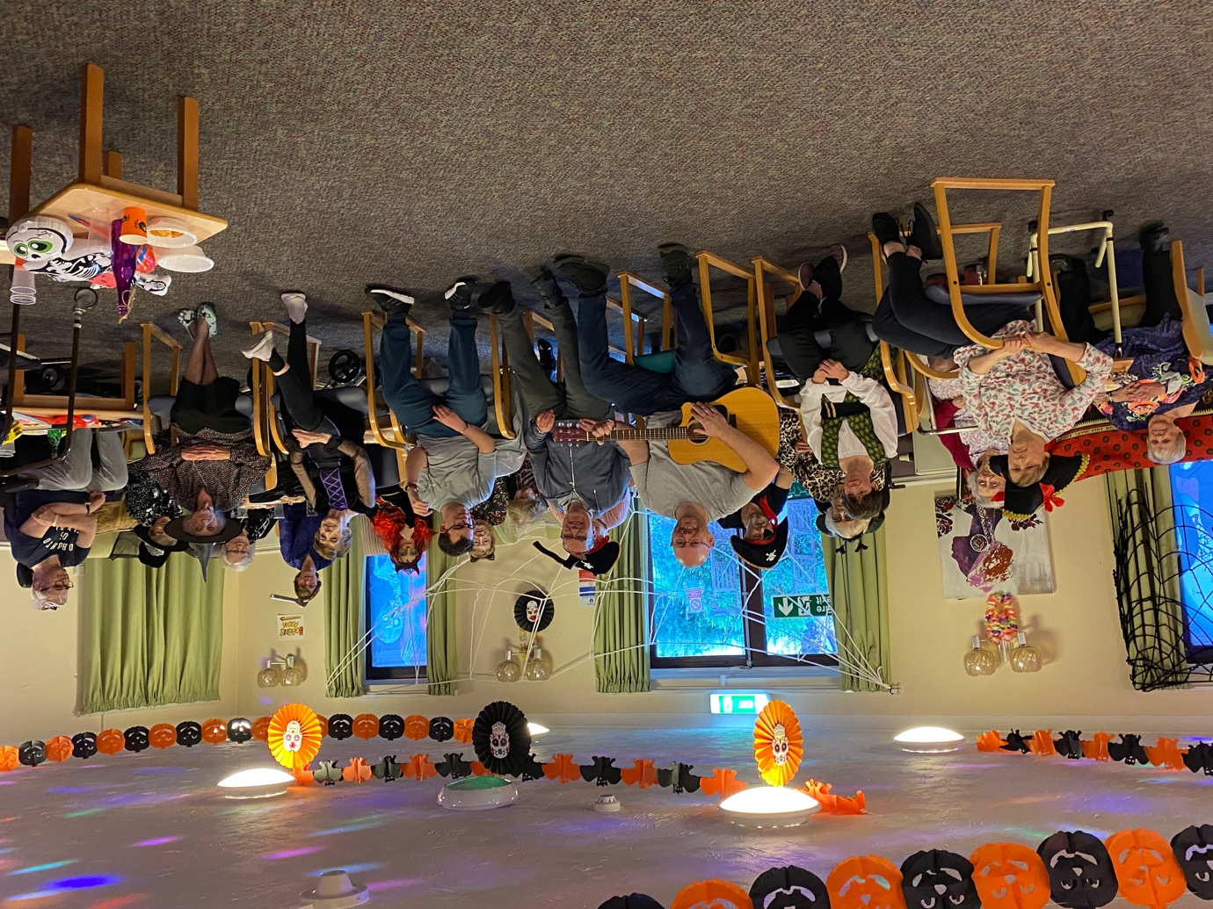
Local Ipswich musician provided the entertainment ©Ambient Support

Ambient Manager at Peppercorn House, Amanda Retter, says:
“Peppercorn House is known to throw a good party and at our summer event it happened that Learning Disability staff were training in the building and mentioned how wonderful it would be to join in… so we thought, why not!?

“Organising the Halloween party was a huge team effort from team leaders to carers and housekeepers to admin staff – everyone went above and beyond, just as they always do, to support the event and to help create a happy and inclusive environment for the people we support. We are delighted that we could welcome people supported from our Learning Disability services for the first time and hope we can continue to do so at other events.”

Sue Brown, Locality Manager of Ambient’s Supported Living services in Suffolk, says:
“It was a fantastic opportunity for the different portfolio communities to interact and benefit from each other’s company.

“Linking the people from our Older People services and people with a Learning Disability seemed such a natural thing to do. Both groups are often at risk of social isolation, and this was a great chance for people to develop new social networks and engage with others.

“Working in a collaborative way is incredibly positive and ultimately it provided a chance for everyone involved to have a bit of good old-fashioned fun. We are looking forward to creating more chances for the people we support to get together!”

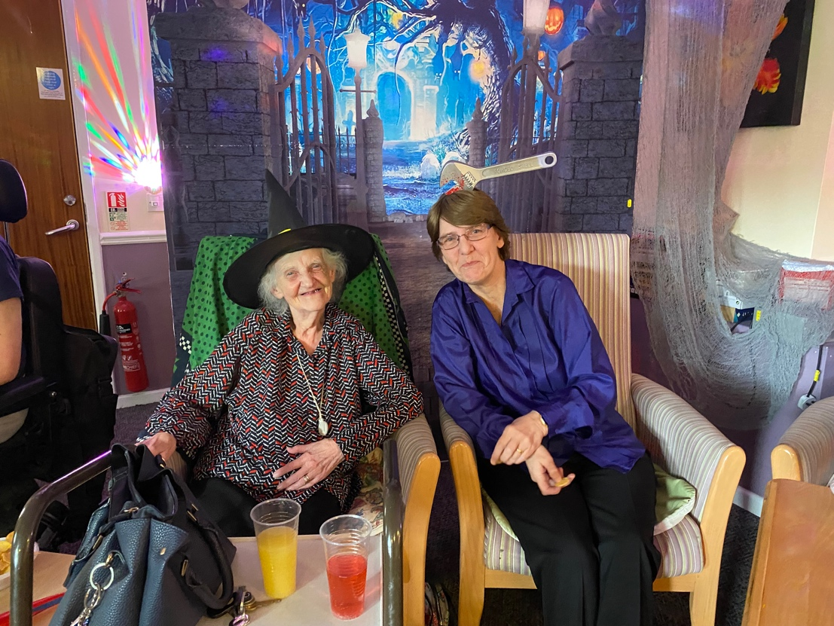
Janet Larter (L) and her daughter (R) enjoying the party

Janet Larter aged 88 from Peppercorn House, says:
“It was a very nice party, we had good company and everyone enjoyed themselves very much.”

Janet’s daughter adds:
“I would like to thank all staff for the great party, they all worked very hard. It has been nice mixing with some of the LD services and their support workers and the music was great.”

Victoria Barnes aged 36 from Ambient’s Learning Disability services, says:
“The party was amazing, I loved the entertainment. The company was good, and I would love to do it again.”

Peppercorn House, Extra Care in Ipswich offers purpose built one bedroomed apartments to the over 60s who wish to live an independent life but may need some extra care and support at times.

Ambient’s Supported Living services in Suffolk enable people to live as independently as possible in a home of their own. This usually means a small group of people sharing a house with their own secure tenancy, with personalised care and support tailored to meet their individual needs provided by Ambient.

Find out more at www.ambient.org.uk

~ENDS~

For more information, images or comment please contact kathy@pr4.com 07788 272 009

Notes to Editors:
About Ambient Support: www.ambient.org.uk @ambientsupport
- Ambient Support is one of the Top 20 generic Not-For-Profit Health & Social Care Providers in the UK
- They deliver services that meet the needs of some of the most vulnerable adults in society
- Operating in 110+ locations, they provide over 30 thousand hours of care to people on a weekly basis to support a range of needs due to the ageing process, learning disability or mental illness
- Ambient is certified as a Great Place to Work following an in-depth survey of staff in October 2022. Survey findings showed that 84% said they felt they made a difference and were proud of what they accomplished. Whilst almost 90% said they are treated fairly, regardless of age, race, or sexual orientation. Similarly, 83% of employees said that when they joined Ambient, they were made to feel welcome
- Ambient’s range of quality specialist services are delivered by dedicated, professional, and passionate staff and their success is built on supporting people to live a full and meaningful life
- Latest results from Ambient Support’s 2022- People We Support Satisfaction Survey show:
82% believe that Ambient supports them to live their life in the way they want to and 85% say we have helped make their lives better since support them.​ A total of 82% of people would tell others that they like Ambient
- Ambient currently supports around 950+ people across the UK in a number of care settings
- Ambient can also help young adults who are transitioning from Children’s to Adult Learning Disability Services
- 89% of CQC registered locations rated Good or Outstanding
- Ambient Support partners with EasyFundraising which allows people to turn their everyday online shopping purchases into donation funds for the charity, without costing extra money. Find out more HERE and visit Ambient’s EasyFundraising link HERE

