Yes You ‘Can’!

Local Man with Down Syndrome Creates ‘Canaries’ Art for his beloved Norwich City Football Club

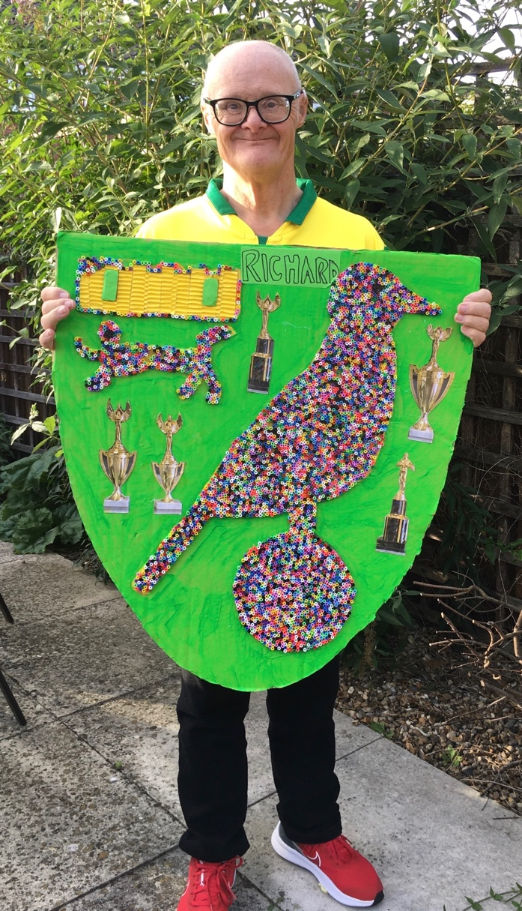
Richard’s Canary was created using hundreds of tiny beads ©Ambient Support

(October 2023) A local man with Down Syndrome has created a football shield using hundreds of tiny beads to celebrate his beloved Norwich City Football Club and raise awareness of the benefits of using art to promote wellbeing.
Richard, who lives in a supported living service run by national charity, Ambient Support, took many hours to make the piece which features Norwich City’s famous ‘Canary’ and wants to share his love of art to encourage others in the Learning Disability community to take up the hobby.

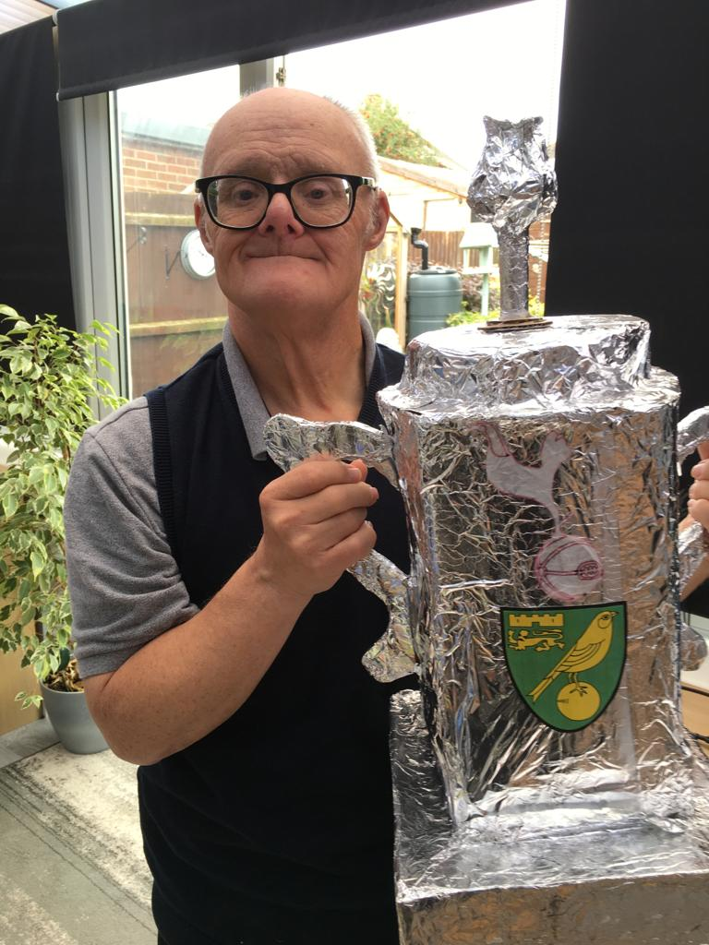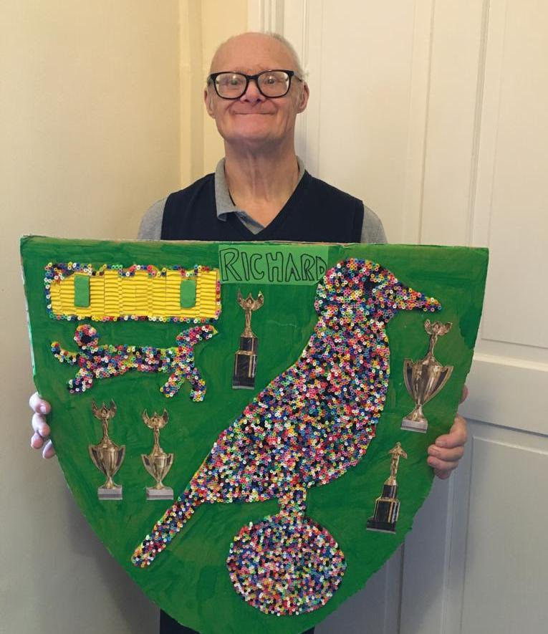
Richard’s Norwich City Football Club artworks ©Ambient Support

Richard, who turns 65 in December, has been supported by Ambient since 2009 and has attended a day service three days a week for 15 years at Norfolk and Norwich SEND Association (NANSA). The organisations work in partnership to ensure that Richard’s love of art is nurtured and developed.

Spending up to 18 hours a week working on his art at the day service, it helps Richard’s wellbeing and mental health.

Josie Bennington, Team Leader at Ambient Support, and Richard’s Keyworker, says:
“Down Syndrome affects people differently. Richard is very healthy, mobile and understands language brilliantly however, he finds it difficult to communicate verbally so will use lots of actions to ensure he is understood.

“Art is extremely therapeutic for Richard. He absolutely loves it and is always busy creating. Our partnership with NANSA ensures that Richard’s passion for art is fully supported and encouraged.

“Richard will bring home one piece a week and he uses his bedroom wall as his canvas to display his work. He creates so much that he needs to store it in his bedroom cupboard and then alternate the pieces as he wishes. We also have his art displayed along the staircase in the house and in the conservatory.

“We also encourage him to create scrapbooks and he’ll spend hours cutting out from newspapers, magazines, colouring books and pictures he’s found on the internet. He has 8 or 9 scrapbooks, all with a different theme including animals, World Wars and of course, football.”

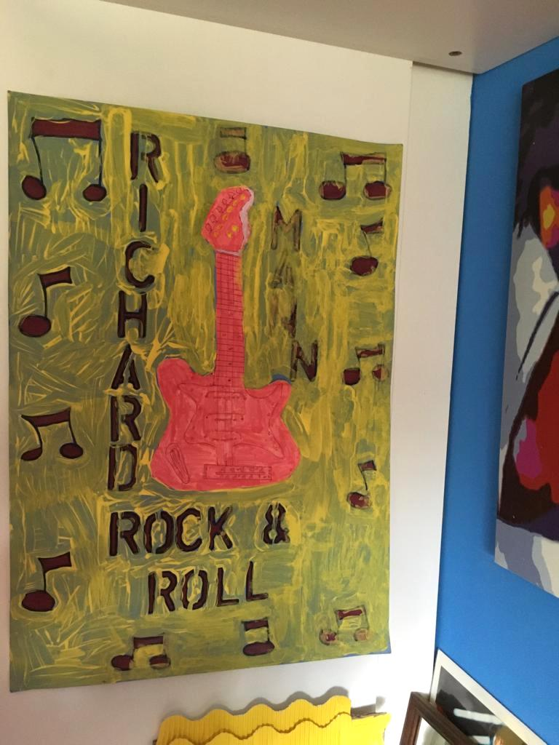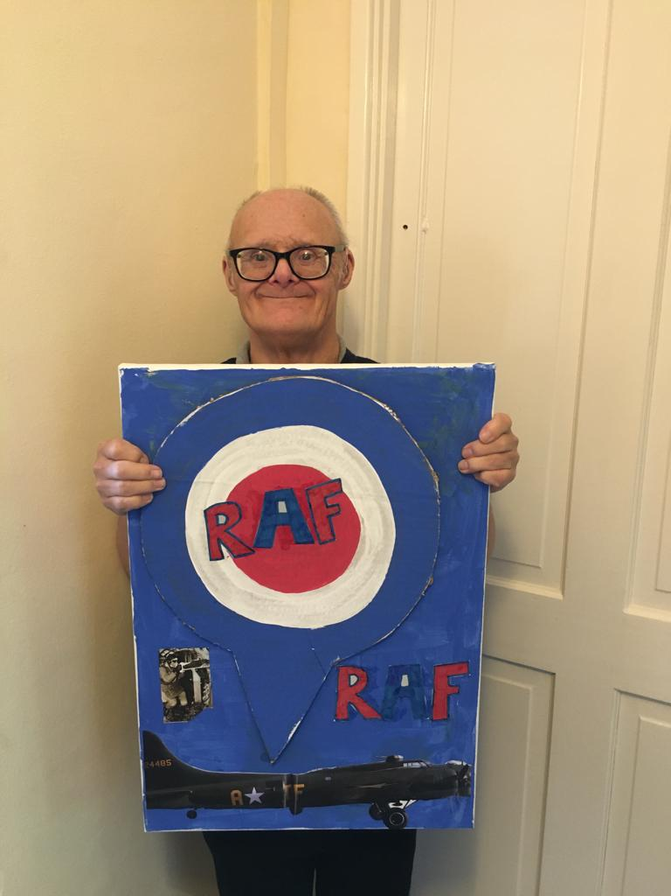
Richard’s bedroom wall and ‘RAF’ artwork ©Ambient Support

Richard is a passionate Norwich City Football Club fan. Pre-Covid he attended many games at Carrow Road Stadium and went along to several ‘Jamie’s Game’ celebrity events where he met a few famous faces.

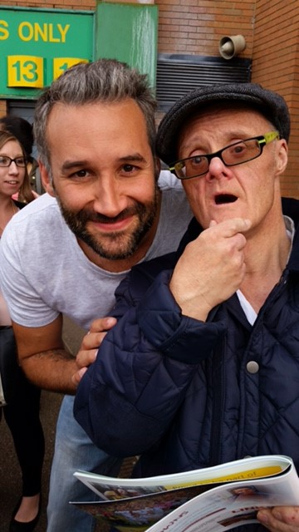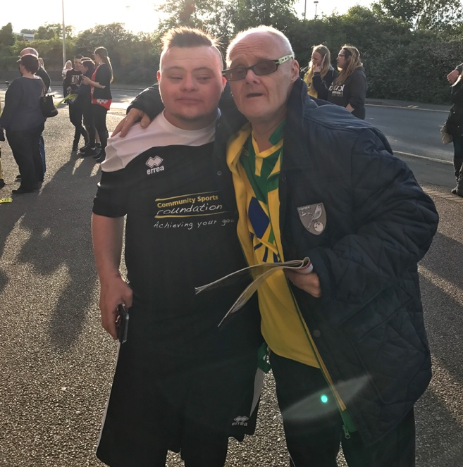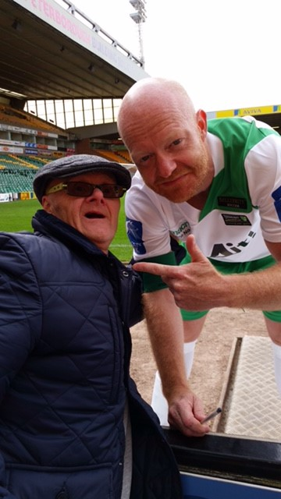
Richard with (L to R) Dane Bowers, Jamie Abbott, Jake Wood at ‘Jamie’s Game’ events

Josie continues:
“Art is instrumental to Richard’s wellbeing- it keeps him very busy and he’s really very good at it, some of his works are amazing and extremely intricate. But his love of football also makes him very happy. Richard watches avidly on television and always has great optimism for a Norwich win- his passion is infectious!”

Josie concludes: “What better time to shine a light on Richard’s artistic achievements than in Down Syndrome Awareness Month this October, which is recognised across the world, and celebrates each individual and tackles stereotypes and myths surrounding the syndrome.”

Find out about Ambient’s Supported Living Service in Norfolk, HERE.

~~ENDS~~

For images or additional comment please contact kathy@pr4.com +44 7788 272 009

Notes to Editors:
About Ambient Support: www.ambient.org.uk @ambientsupport
- Ambient Support is one of the Top 20 generic Not-For-Profit Health & Social Care Providers in the UK
- They deliver services that meet the needs of some of the most vulnerable adults in society
- Operating in 110+ locations, they provide over 30 thousand hours of care to people on a weekly basis to support a range of needs due to the ageing process, learning disability or mental illness
- Ambient is certified as a Great Place to Work following an in-depth survey of staff in October 2022. Survey findings showed that 84% said they felt they made a difference and were proud of what they accomplished. Whilst almost 90% said they are treated fairly, regardless of age, race, or sexual orientation. Similarly, 83% of employees said that when they joined Ambient, they were made to feel welcome
- Ambient’s range of quality specialist services are delivered by dedicated, professional, and passionate staff and their success is built on supporting people to live a full and meaningful life
- Latest results from Ambient Support’s 2022- People We Support Satisfaction Survey show:
82% believe that Ambient supports them to live their life in the way they want to and 85% say we have helped make their lives better since support them.​ A total of 82% of people would tell others that they like Ambient
- Ambient currently supports around 950+ people across the UK in a number of care settings
- Ambient can also help young adults who are transitioning from Children’s to Adult Learning Disability Services
- 89% of CQC registered locations rated Good or Outstanding
- Ambient Support partners with EasyFundraising which allows people to turn their everyday online shopping purchases into donation funds for the charity, without costing extra money. Find out more HERE and visit Ambient’s EasyFundraising link HERE

