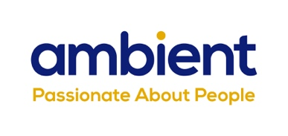
Celebrating Stories of Achievement on International Day of People with Disabilities

(November 2023) National charity, Ambient Support will be marking the United Nations ‘International Day of People with Disabilities’ (IDPWD) on 03 December by highlighting six inspirational stories of the people it supports across its Learning Disability and Mental Health services.

IDPWD recognises and promotes the rights of people with disabilities in all areas of society and aims to increase the awareness and wellbeing of disabled people in all aspects of their life.

Vicky Morris, Head of Quality at Ambient Support, says:
“At Ambient, we recognise the importance of providing person-centered and active support which allows individuals to gain new skills, increase their confidence and take control of their lives, becoming valued and contributing members of society.

“These heart-warming stories are incredibly inspirational and are clear examples of how giving the right support at the right time ensures the individuals we support can live life as they wish to. I would like to congratulate Darren, Ele, Michael, Kenny, Richard and Chris for their determination, hard work and courage and their support workers for going above and beyond and providing essential support to help them achieve their aims.”

DARREN’S VOLUNTEER WORK

Darren has always loved motorbikes. His favourite bike is a Kawasaki Ninja and he’s even met his idol, John McGuiness a Tourist Trophy races (TT) rider. When Darren first moved to Ambient’s supported living service for Learning Disability in Staffordshire, his Team Leader, Melissa Gadd, was keen to understand his likes and interests and soon discovered that Darren has a real passion for motorbikes and mechanics.

Melissa spoke to the local mechanics garage, DK Motorcycles, and asked if it was possible for Darren to trial voluntary work for one day a week. They agreed and Darren has been volunteering at DK Motorcycles for two and a half years and is absolutely thriving in the workplace.

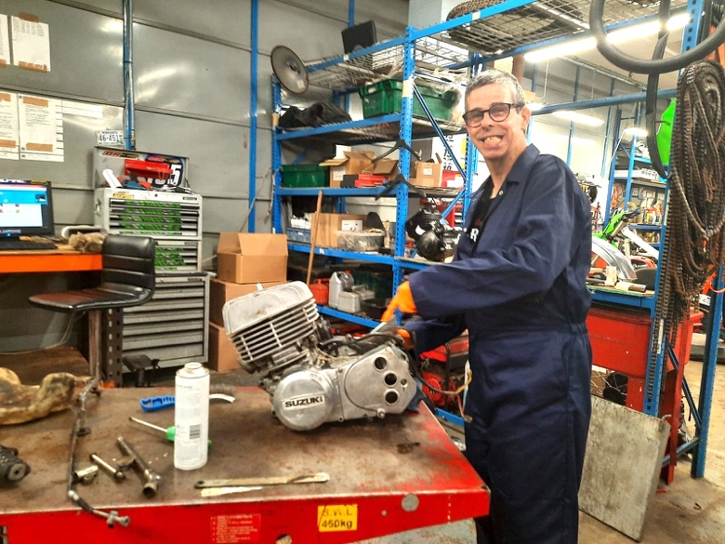
Darren has a keen interest in motorbikes

ELE’S HAIRDRESSING VOLUNTEER WORK

Ele has been volunteering every Friday at her local hairdressers for over 10 years – she loves helping and feeling part of the team and always looks forward to it. Well-known by the regular clients, Ele enjoys interacting with people and the work helps her to feel valued and included in the community.

Ele has been at one of Ambient’s supported living services in Bourne, Lincolnshire, since 2018 and her Service Lead, Daina Sevcika, is incredibly mindful of encouraging Ele to do as much as she can independently – and not to step in where it’s not necessary. Daina says:

“Our aim is to make sure that Ele’s life is as close to a normal life as possible as it’s a step forwards towards independence. Ele always comes back from the hairdressers happy and fulfilled, it definitely boosts her mental health and we are very grateful to Halo in St Catherine’s Road, for continuing to give Ele this opportunity.”
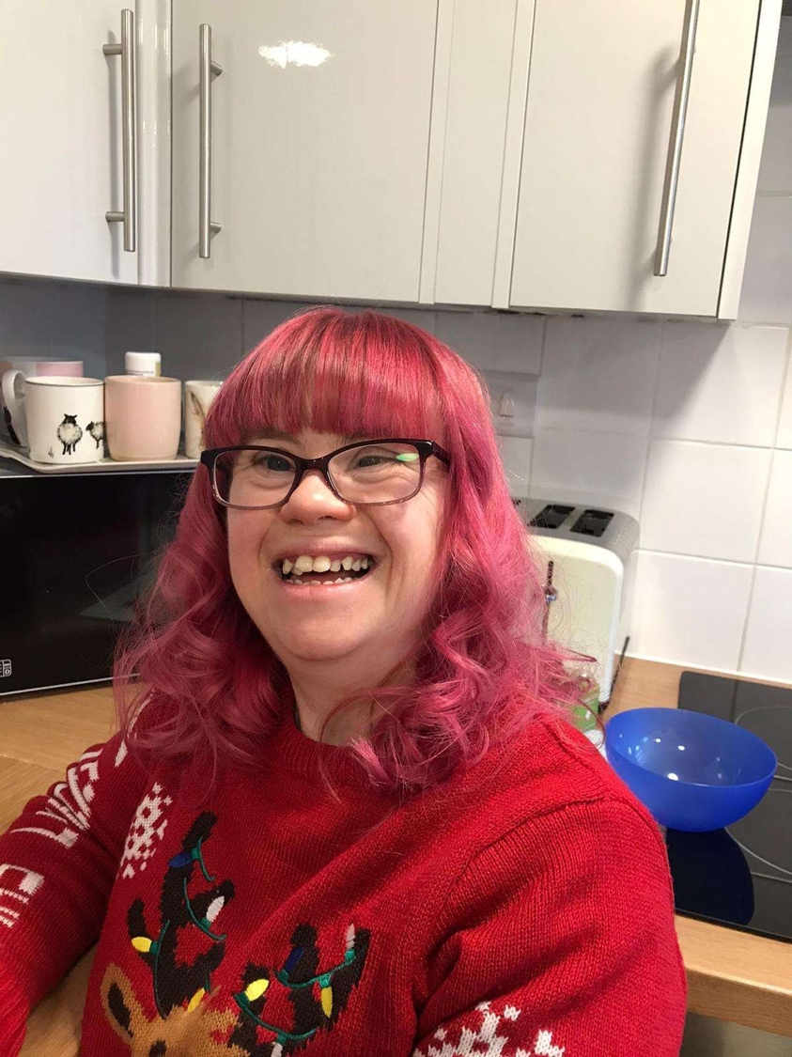
Ele volunteers at the local hairdressers, Halo, where she also gets her hair cut and styled ©Ambient Support

MICHAEL’S JOB ROLE

Michael Neave with Autism became a qualified support worker at a learning disability service in Norfolk run by Ambient Support. With specialist help from his Team Leader, Sarah Green, Michael is the first person with Autism to achieve employment status at this supported living service. Michael, 44 and from Norwich, was diagnosed with Autism in 2012 and in 2015 started supporting nonspeaking individuals at Autism Anglia. He began training with Ambient in 2022 and was mentored by Team Leader, Sarah Green, who helped him to qualify. Sarah says:

“We look at Michael’s Autism as his superpower – he can relate to, understand, and connect with the people we support from a unique perspective. You only get this deep understanding if you’re able to support people with disabilities in the workplace. It helps that Michael is very open and honest about his Autism. He can communicate well about what he needs, and it allows us to support him better.”
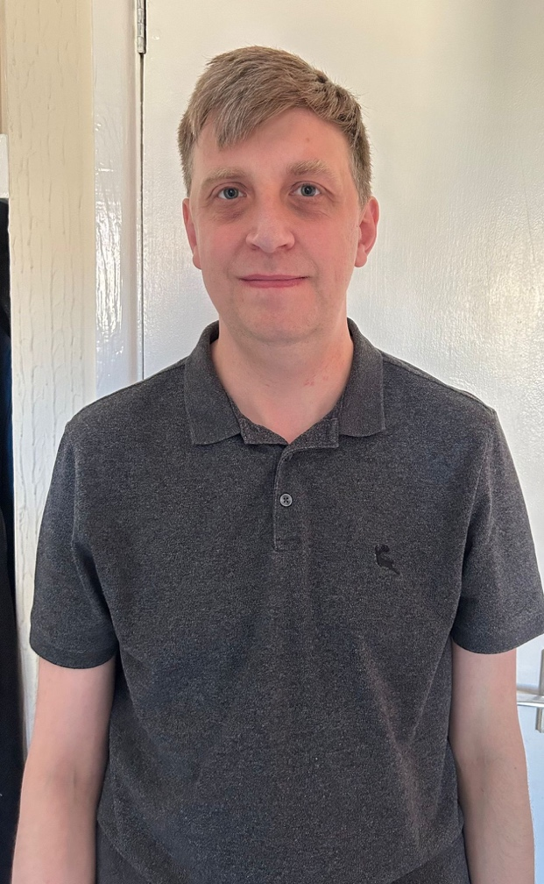
Michael is the first person with Autism to achieve employment status at the supported living service ©Ambient Support

KENNY’S LOVE OF WOODWORK

Kenny is supported at one of Ambient’s supported living services in Derby in the Midlands, and with the encouragement of Lindsey, his Support Worker and the Service Lead, Kenny has been going to Woodworking class every Thursday morning for the last year - it’s become the highlight of his week. The classes are held at The Mixed Craft Workshop in Derby, a creative and fun place for adults living with a disability or long-term health condition.

Kenny enjoys gardening and being outside so is incredibly proud of his recently finished Bird table which took him 4 months of hard work to make, he is now working on two wooden planters for his garden. His main goal is to make a summer chair to go in his garden.

Previously, Kenny struggled with socialising and maintaining friendships, but since joining the class his social life is thriving and he has formed some solid friendships which has positively affected his general well-being. He started bringing cakes and biscuits in for his friends to share in class, and now goes to events outside of class with them including the pub for meals.

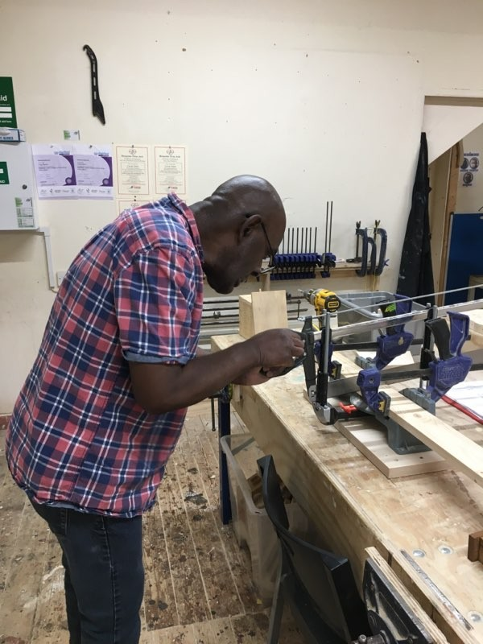
Kenny has built a bird box which is now in his garden ©Ambient Support

CHRIS WALKS THE WASH

Chris, with autism spectrum disorder (ASD), lives in supported living accommodation in Lincolnshire and took two years to walk the Wash to raise awareness of Autism and to promote the Wash becoming a UNESCO World Heritage Site. Chris, age 51, completed his 42-mile challenge in small 3-to-4-mile sections to overcome logistical obstacles and fitness limitations such as Chris’ asthma. He was supported throughout his journey by his Support Workers; Sylwester Oleksiewicz, Tomasz Wilf, Alex Kay and team leader Kim Wainwright, from an Ambient Support’s Learning Disability Service in Lincolnshire.

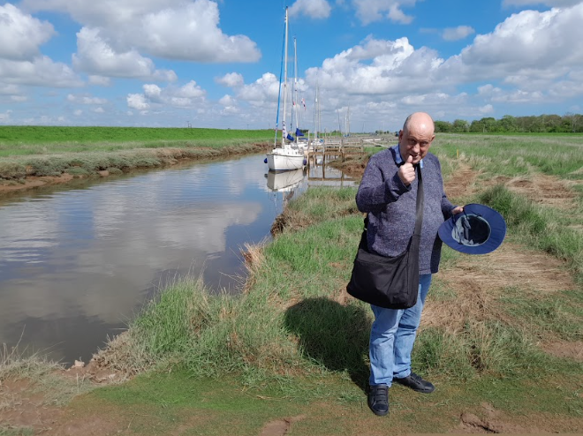
Chris Walked the Wash with his Support Worker, Sylwester ©Ambient Support

RICHARD’S ART

Richard with Down’s Syndrome created a football shield using hundreds of tiny beads to celebrate his beloved Norwich City Football Club and to raise awareness of the benefits of using art to promote wellbeing. Richard lives in a supported living service and took many hours to make the piece which features Norwich City’s famous ‘Canary’ - he wanted to share his love of art to encourage others in the Learning Disability community to take up the hobby. Richard, who turns 65 in December, has been supported by Ambient since 2009 and has attended a day service three days a week for 15 years at Norfolk and Norwich SEND Association (NANSA). The organisations work in partnership to ensure that Richard’s love of art is nurtured and developed and he spends up to 18 hours a week working on his art at the day service, which helps Richard’s wellbeing and mental health.

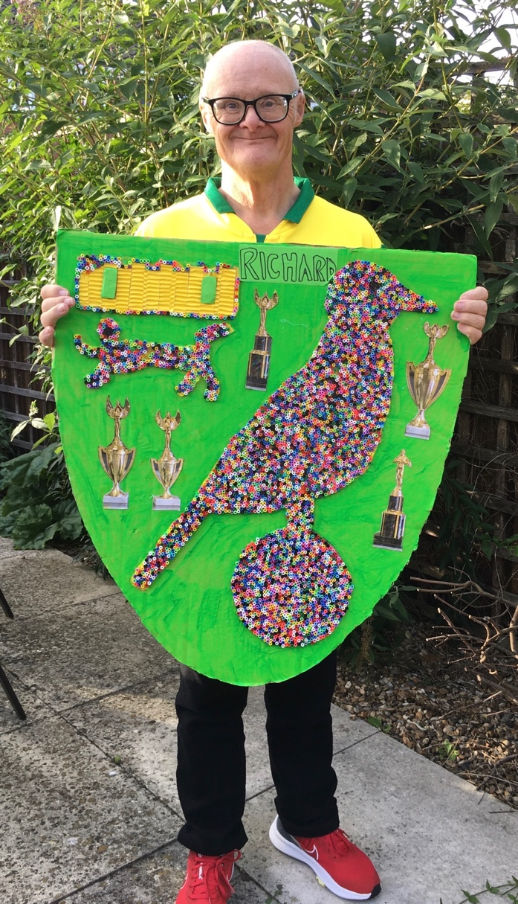
Richard’s Canary was created using hundreds of tiny beads ©Ambient Support

Find out more at www.ambient.org.uk

~ENDS~

For more information, images or comment please contact kathy@pr4.com 07788 272 009

Notes to Editors:
About Ambient Support: www.ambient.org.uk @ambientsupport
- Ambient Support is one of the Top 20 generic Not-For-Profit Health & Social Care Providers in the UK
- They deliver services that meet the needs of some of the most vulnerable adults in society
- Operating in 110+ locations, they provide over 30 thousand hours of care to people on a weekly basis to support a range of needs due to the ageing process, learning disability or mental illness
- Ambient is certified as a Great Place to Work following an in-depth survey of staff in October 2022. Survey findings showed that 84% said they felt they made a difference and were proud of what they accomplished. Whilst almost 90% said they are treated fairly, regardless of age, race, or sexual orientation. Similarly, 83% of employees said that when they joined Ambient, they were made to feel welcome
- Ambient’s range of quality specialist services are delivered by dedicated, professional, and passionate staff and their success is built on supporting people to live a full and meaningful life
- Latest results from Ambient Support’s 2022- People We Support Satisfaction Survey show:
82% believe that Ambient supports them to live their life in the way they want to and 85% say we have helped make their lives better since support them.​ A total of 82% of people would tell others that they like Ambient
- Ambient currently supports around 950+ people across the UK in a number of care settings
- Ambient can also help young adults who are transitioning from Children’s to Adult Learning Disability Services
- Ambient Support partners with EasyFundraising which allows people to turn their everyday online shopping purchases into donation funds for the charity, without costing extra money. Find out more HERE and visit Ambient’s EasyFundraising link HERE

