Runners take on iconic London Landmarks Half Marathon Raising £5.5K for Life Changing Tech

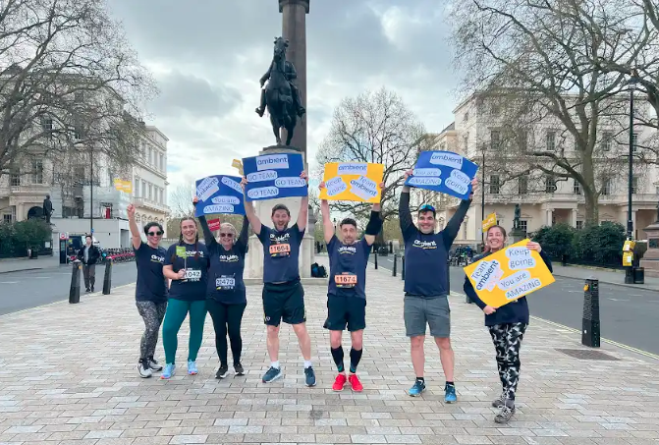
Ambient Support runners took part in the London Landmarks Half Marathon on 07 April

(09 April 2023) A team of 9 runners, nicknamed the ‘Nimble Nine’, completed the London Landmarks Half Marathon (LLHM) on 07 April in a bid to raise funds for a large interactive digital tablet for a learning disability and short breaks service in Widmore Road, Bromley, which is run by national charity, Ambient Support.

So far, the Nimble Nine team has raised £5,593 of its £7,000 target which will cover the cost of the touch table. The technology is designed specifically for the care and education sector and Sara Barton, Scheme Manager at the Widmore service is encouraging locals to donate to help the team raise the remaining £1,407 needed to purchase the kit. Sara says:

“It’s an amazing piece of technology that gives people opportunities to learn, have fun, play games, and experience something totally new. This enriching and engaging tool will have a real positive impact on all those who visit Widmore Road, as well as providing our incredible staff with a new way of expanding the experiences of the people they support. We really hope that locals in the area and the wider community get behind the team and donate!”

The LLHM is a closed road, central London run and is the only half marathon to go through both the City of London and City of Westminster. Raising thousands of pounds for charity every year, runners race past landmarks including Big Ben, London Eye, St Paul’s Cathedral and Tower Bridge and the route also offers entertainment along the way including musical performances, DJs, dancers and themed cheer stations.

The running team consisted of 9 individuals - all of whom have connections with Ambient Support including family and friends of employees, and organisations and agencies who work with the charity.

Runner, Piero Barba from Cross Origin, says:
“We’ve worked closely with Ambient for many years and see incredible hard work at all levels of the organisation. The charity is always looking for ways of raising funds to further its ability to provide outstanding care for the people it supports and we’re delighted to be able to help.”

The nine runners who completed the race are Lauren Jolley, Chrissie Blake, Johann Tritthardt, Phillipa Jones, Tim Vaughan, Piero Barba, Sam Parkins, Simon Thornhill and Toni Spellar. Simon finished 29th overall in just 1 hour and 19 minutes.

Davina Sellick, Director of Business Development & Communications at Ambient Support, says:
“This is the first time the charity has taken part in an organised running race and it’s been brilliant to bring people within our charity and our partners together to fundraise. We’re incredibly grateful to our runners and to everyone who has generously donated. Hopefully, Ambient will get involved next year and raise even more!”

Sara continues:
“We named the team the ‘Nimble Nine’ as we think it’s just brilliant. We know it takes a lot of hard work, training, and time from their personal lives to be able to run such a long distance so we’re incredible thankful to everyone involved.”

Sara is asking locals to get behind the ‘Nimble Nine’ and donate – https://www.justgiving.com/campaign/ambientruns2024

Widmore Road provides a range of services for people with learning disabilities and complex needs living in the Bromley area, offering fun and fulfilling person-centred activities and experiences, whilst providing respite for families.

For more details on Ambient services at Widmore Road click HERE and see the virtual tour of the service HERE.

~ENDS~

For more information, images or comment please contact kathy@pr4.com 07788 272 009

Notes to Editors:
About Ambient Support: www.ambient.org.uk @ambientsupport
- Ambient Support is one of the Top 20 generic Not-For-Profit Health & Social Care Providers in the UK
- They deliver services that meet the needs of some of the most vulnerable adults in society
- Operating in 110+ locations, they provide over 30 thousand hours of care to people on a weekly basis to support a range of needs due to the ageing process, learning disability or mental illness
- Ambient is certified as a Great Place to Work following an in-depth survey of staff in October 2022. Survey findings showed that 84% said they felt they made a difference and were proud of what they accomplished. Whilst almost 90% said they are treated fairly, regardless of age, race, or sexual orientation. Similarly, 83% of employees said that when they joined Ambient, they were made to feel welcome
- Ambient’s range of quality specialist services are delivered by dedicated, professional, and passionate staff and their success is built on supporting people to live a full and meaningful life
- Latest results from Ambient Support’s 2023- People We Support Satisfaction Survey show:
84% say they are happy with the care Ambient provide, 82% feel that their lives have improved since Ambient started supporting them and 93% agree that they would recommend Ambient Support
- Ambient currently supports around 900+ people across the UK in a number of care settings
- Ambient Support partners with EasyFundraising which allows people to turn their everyday online shopping purchases into donation funds for the charity, without costing extra money. Find out more HERE and visit Ambient’s EasyFundraising link HERE

